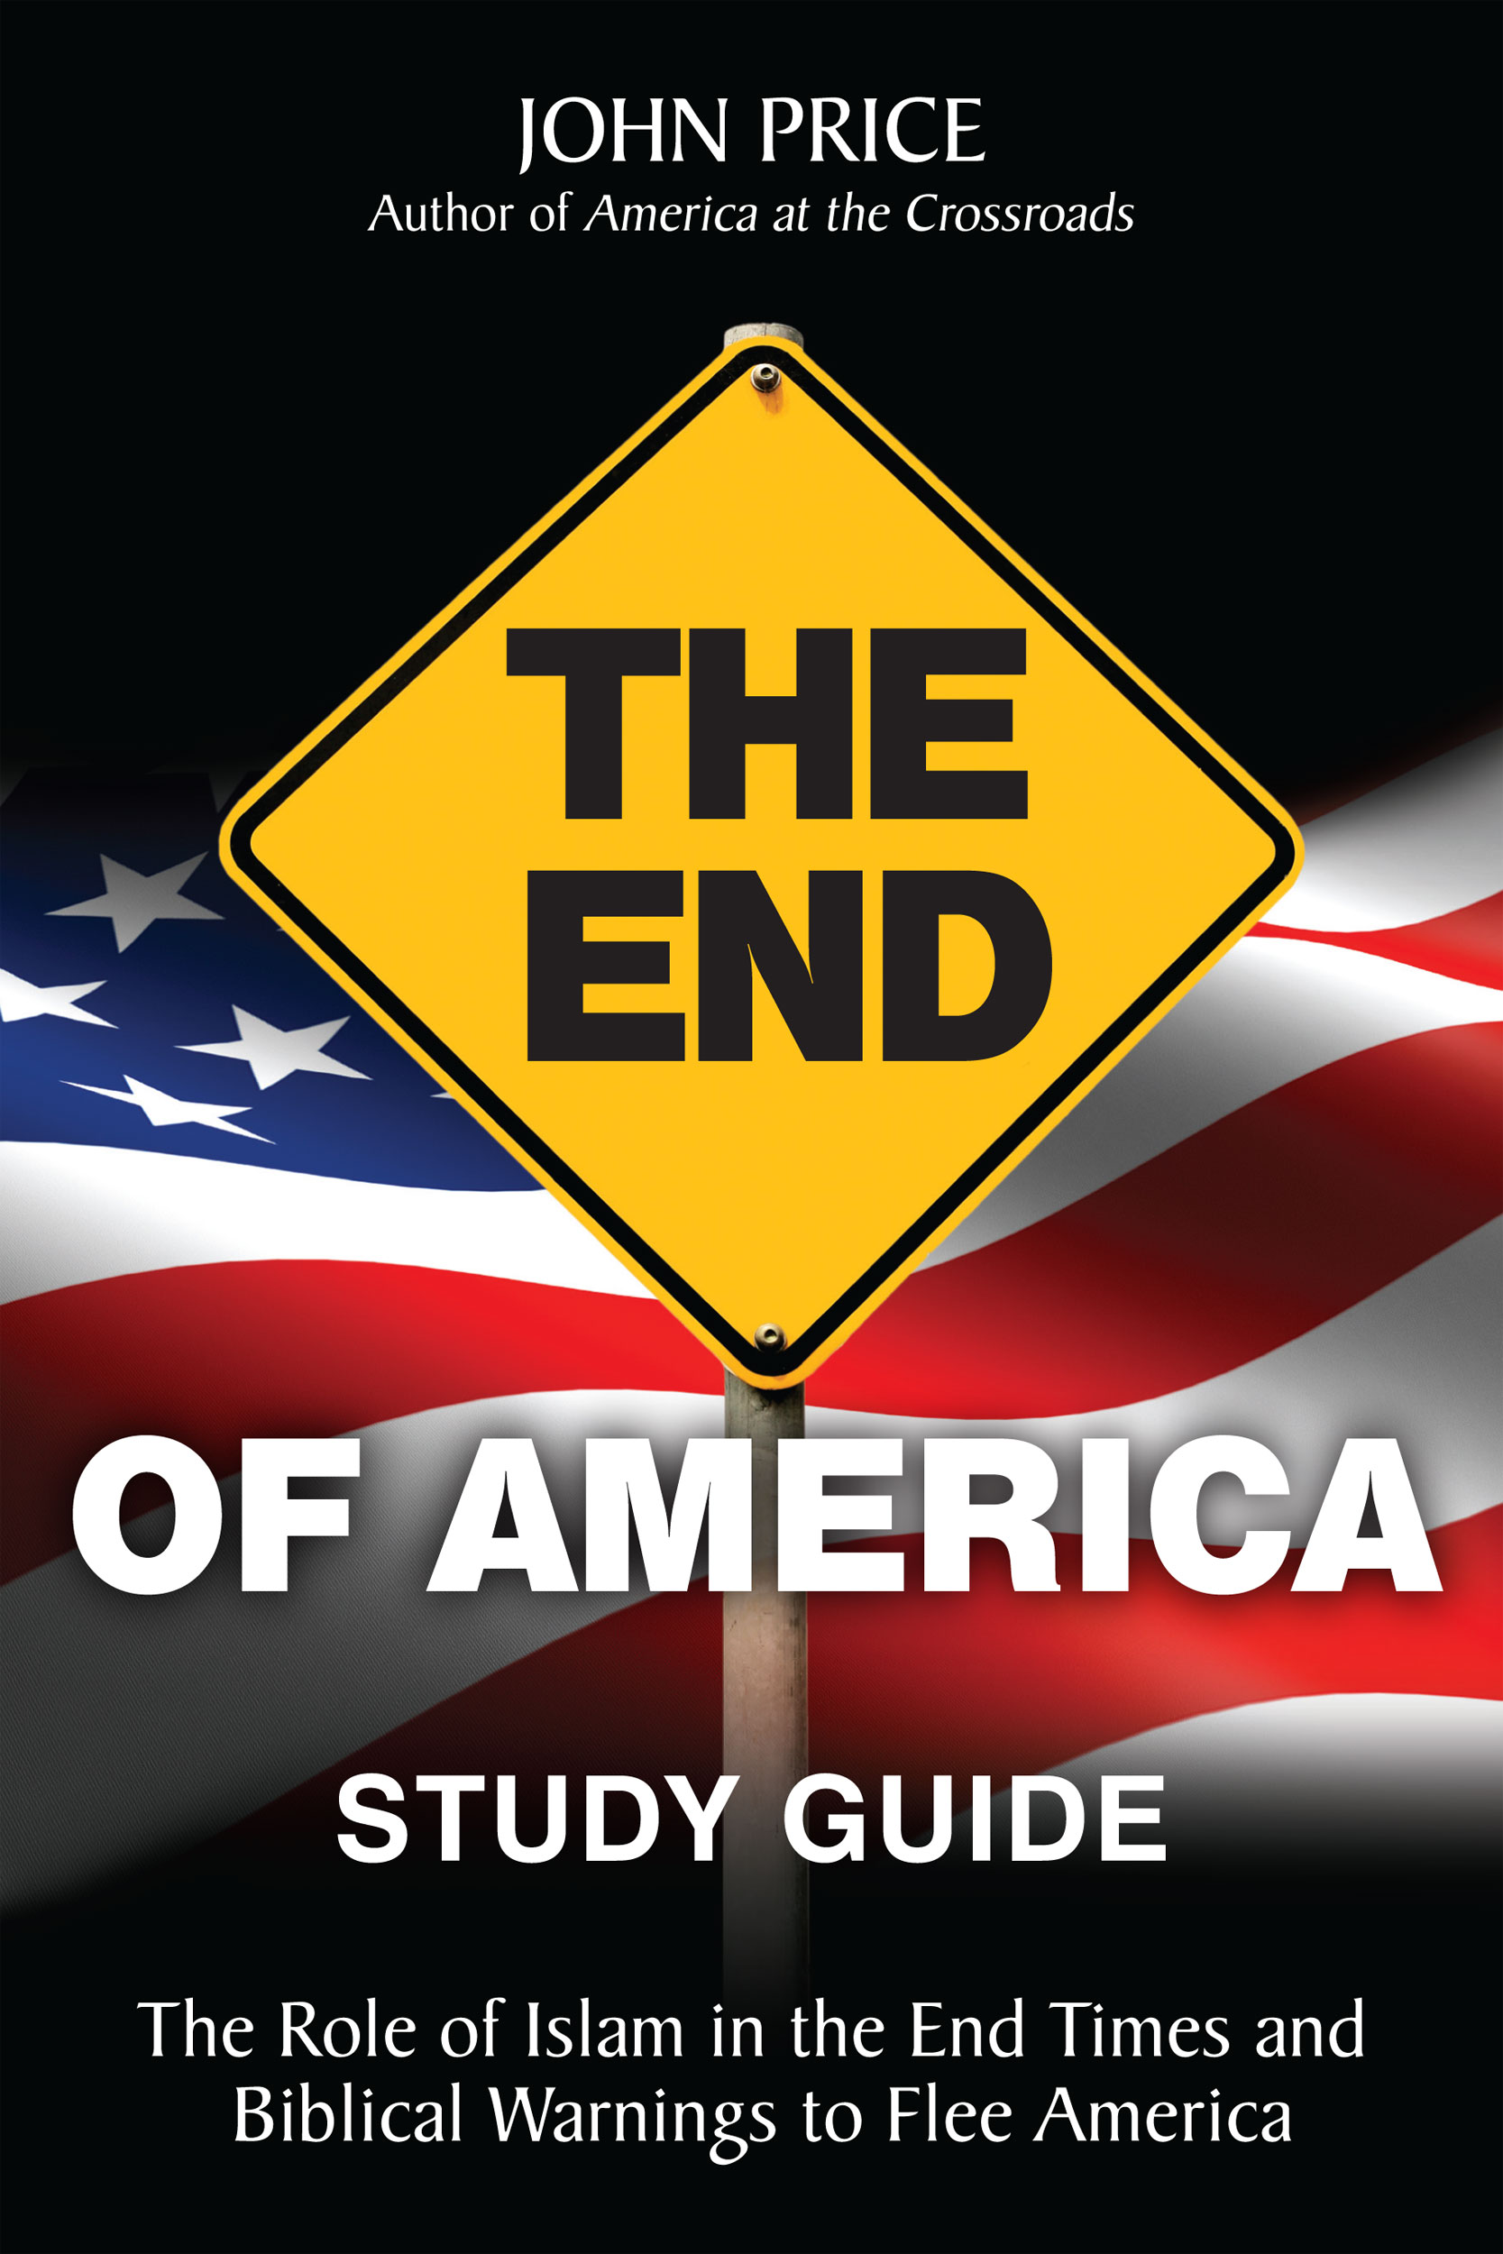

**THE END OF AMERICA**

**STUDY GUIDE**

**by**

**John Price**

**This Study Guide is based on THE END OF AMERICA. It contains thirteen lessons, allowing its use in a quarter of the year. It is structured to be used in a small group setting or an adult Sunday school. It is recommended that students using the Study Guide also read THE END OF AMERICA. The Study Guide is formatted in a question style to encourage prior study by students and a full discussion by members of the group, as encouraged and facilitated by the teacher/leader/facilitator.**

**Teachers, as well as students, may wish to visit** [**www.endofamericabook.com**](http://www.endofamericabook.com)**. The book website includes a lengthy article entitled Prophecy 101, found at the Prophecy tab. Another article details Scripture set forth in THE END OF AMERICA, including a look at Hebrew and Greek source words. A one hour video on the subject is included on the website, as well as a link to Amazon and Kindle. A bibliography is included at the end of the Study Guide.**

**This STUDY GUIDE is NOT copyrighted, so as to encourage its free use by American Christian and Jewish leaders interested in learning what the Bible says will happen to their country in its future. No waiver or license, though, is granted for its alteration or misuse.**

**John Price**

**E-mail at** [**www.endofamericabook.com**](http://www.endofamericabook.com)

**THE END OF AMERICA**

**STUDY GUIDE**

**TABLE OF CONTENTS**

**Lesson One – Introduction – Is America in the Bible?**

**Lesson Two – The Mystery of the Identity – Clues 1, 2, 3**

**Lesson Three - The Mystery of the Identity – Clues 4, 5, 6**

**Lesson Four - The Mystery of the Identity – Clues 7, 8, 9**

**Lesson Five - The Mystery of the Identity – Clues 10, 11, 12**

**Lesson Six - The Mystery of the Identity – Clues 13, 14, 15**

**Lesson Seven - The Mystery of the Identity – Clues 16, 17, 18**

**Lesson Eight - The Mystery of the Identity – Clues 19, 20, 21**

**Lesson Nine – Prophecy’s Abomination Nation Clues A, B, C**

**Lesson Ten - Prophecy’s Abomination Nation Clues D, E, F**

**Lesson Eleven - Prophecy’s Abomination Nation Clues G, H, I**

**Lesson Twelve – Events that Will Occur Before Babylon’s Fall**

**Lesson Thirteen – More Events that Will Occur Before the Fall**

**THE END OF AMERICA**

**STUDY GUIDE**

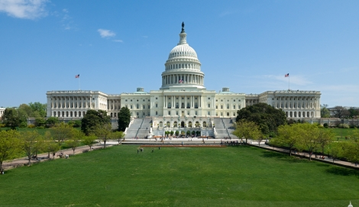

**LESSON ONE**

**INTRODUCTION - IS AMERICA IN THE BIBLE?**

**I. Does God Have the Ability to Name/Portray a Nation/Leader in Advance of its/his Appearing?**

Let’s face it. If God is limited in His ability or power to see the future, then we don’t need to study this topic (or the Bible for that matter) any further. Bible study over….let’s party! But He’s not limited regarding the future.

*“Who foretold this long ago, who declared it from the distant past?”* (Isaiah45:21) God asserts His diety, in part, through His amazing ability to foresee, accurately, the future. The underlying integral component of this prophetic power is His ability to make the things He foresees *actually come to pass*. *Just as He said.*

**1.** What are some examples of this power and ability in scripture? Your assignment to give the location by verse in scripture of a prophecy concerning a nation or its king, then list the verse location for the fulfillment of the prophecy. Here’s an example to get you started. God said in Isaiah 44:28 that a future leader named Cyrus would come to power and he would be instrumental in Israel’s future:

**THE PROPHECY -ISAIAH 44**

**24**“This is what the Lord says—

**26**who carries out the words of his servants  
    and fulfills the predictions of his messengers,

who says of Jerusalem, ‘It shall be inhabited,’  
    of the towns of Judah, ‘They shall be rebuilt,’  
    and of their ruins, ‘I will restore them,’

**28**who says of Cyrus, ‘He is my shepherd  
    and will accomplish all that I please;  
he will say of Jerusalem, “Let it be rebuilt,”  
    and of the temple, “Let its foundations be laid.”’

ISAIAH 45

**3**I will give you hidden treasures, riches stored in secret places, so that you may know that I am the Lord, the God of Israel, who summons you by name. (Isaiah 45:3)

THE FULFILLMENT OF THE PROPHECY

**2 Chronicles 36:23 (also Ezra 1:2)**

Thus saith **Cyrus** king of Persia, All the kingdoms of the earth hath the LORD God of heaven given me; and he hath charged me to build him an house in **Jerusalem**, which is in Judah

Cyrus founded Persia and became its King in 559 BC. He conquered the Medes and consolidated the Medo-Persian Empire. Once Cyrus was King he was shown the above stated Biblical prophecies. The result? He fulfilled what was written by God many years before, confirming, again, His diety.

OK. Now what do you find in your research?

The Prophecy Stated:

The Prophecy Fulfilled:

(If you have the time, research and state more than one prophecy.)

Bonus Question – Which other King did God name in scripture well before he was born?

**II. Are Nations Specifically Named in the Bible?**

**2.** The Bible contains prophecies concerning Damascus (Isaiah 17, Jeremiah 49, Amos 1 and Jeremiah 9) and Egypt (Isaiah 19 and Psalm 83, among hundreds of others). Both are specifically named in the Bible. Did they exist at the time the Prophets listed them? How do we know that?

**3.** What other nations are named in scripture? Can you find a nation referenced in scripture? What is its name today?

**4.** Is China named in the Bible? Is it alluded to in any way? Read Revelation 16:12. Who is pictured here?

Read Revelation 9:13-16. A two hundred million man army is prophesied. When John wrote these words it is estimated that the approximate population of the world was somewhere between 15 and 50 million. Since a single army as large as 200,000,000 was of course impossible then, what do we deduce about this prophecy? When will it happen? Could it have happened before our times? Why not? What is the population of China today? Could a 200 million man army be raised in a country the size of China? Do China’s birth control policies have any influence on these issues? In what way? Does China have a reserve army? What is its size? What do we deduce about the possibility of the above prophecies from Revelation being fulfilled in our time?

**5.** Do other nations appear in the Bible in a similar way?

**III. Is the Name of America Any Where in the Bible?**

**6.** Let’s put it a different way. If God had said in Jeremiah:

*JEREMIAH 53*

*1. This is the word the LORD spoke through Jeremiah his prophet concerning the great end times nation, that will come to be known as America, 2. to the daughter of the nation that will be called Britain. 3. The nation that will be the hammer of the whole earth reaching up into the heavens. 4. The nation to whom the nations will flow and gather together. 5. America will be a rich, sumptuous nation overflowing with wealth and splendor, dwelling on many waters. 6. A nation to be one of the youngest of the world’s great nations. 7. One nation formed out of many nations, melted together in a pot. 8. The center of the world’s trade in fine goods among nations. 9. Speaking its Great Voice to all people in all lands, and carrying its culture, in which it is mad on its worldly idols, to all who have eyes to see and ears to hear. 10. The land that had in the past, been used by the LORD as a golden cup. 11. A land with many descendants of Abraham, Isaac, and Jacob. 12. And a land with deep water ports to, which the merchants of the earth sell and buy their goods. 13. To this nation, here is what the LORD says will be your future.*

Besides the fact that Jeremiah has only 52 chapters, could God the Holy Spirit have led Jeremiah, or any other Biblical prophet, to have written such specific words as these? If He had done so, do you think newly formed nations would have adopted the name of America? How would history have been affected? Is this why God did not give the actual name of America in scripture, though He could have?

**7.** What have Biblical scholars written on the subject of America in the Bible? Google it, research it and plan to share with the group what you find. Here are comments by two Biblical scholars:

*“Does the United States have a place in end times prophecy? My first response is no, there is nothing about the U.S. in prophecy. At least nothing that is specific…The question is why? Why would the God of prophecy not refer to the supreme superpower nation in the end times in preparation for the one-world government of the Antichrist?”* (Tim LaHaye’s Perspective, August, 1999)

*“The absence of any mention (in the end times) of a nation we could say is the United States, therefore, is a cause for great distress among those of us who live in and love this nation. Where will America be at that time? The conclusion we must draw is very sad and sobering, and it should serve as a loud warning to our beloved United States. Simply put, the United States will no longer be a world power in the end times. It will not be a significant enough nation to play a major role in the events of those days – that is the obvious answer.”* (*Jerusalem: Where Empires Die,* Lester Sumrall, Sumrall Publishing).

**8.** Let’s discuss the obvious options on the question of America’s role in prophecy. With which option do you agree?

**a.) The Time Is Not Right** -America is not mentioned, nor portrayed, because the end times/day of the Lord/final days are centuries/millennia ahead in the future. The nation will have faded away and be gone in a few hundred years. Discussion Point – What is the primary Biblical prophecy problem with this view?

**b.) God Goofed** – Take your pick: A.) God overlooked America’s role in the end days? B.) He forgot what its role would be when He spoke to the Prophets? C.) He saw what would happen, but He couldn’t get any Prophet to write it down? D.) He just didn’t have the ability to see the future of such a big and powerful country? E.) The story of what would happen was too scary to include in prophecy? What is the primary Biblical prophecy problem with this view?

**c.) America is Off the Stage for the Last of the Final Days** – As Dr. Sumrall surmised, the nation of America loses its significance in the final days of the end times. Scripture pictures this critically important nation, but doesn’t mention it after a point in time in the end times prophetic verses. Is there a Biblical problem with this view?

**9.** How does one’s view of this issue affect one’s future plans? If America isn’t in scripture, then does that induce some Americans to ignore Christ, the Bible, etc. due to the omission? If America is included, and has a significantly dire future, how should that affect a Christian/Jew’s thinking about his/her future? In what way?

**10.** Is America pictured, described, alluded to, set forth in the Bible? If you’re not yet sure, stay tuned for future lessons. God has given us thirty clues to solve “*the mystery of the identity*” of a great, rich, powerful end times nation. Next, we’ll start examining those clues. Here are three clues describing this nation to munch on:

1.) Hammer of the whole earth.

2.) The great voice.

3.) “Hindermost” (latter day) nation.

Could these clues apply to the US?

**LESSON TWO**

**“The Mystery of the Identity” – 21 Identity Clues**

**(THE END OF AMERICA – CHAPTER FOUR)**



**Hercule Poirot, Master Detective**

**I. Does God Really Use the Word ‘Mystery’ in the Bible? Why?**

*“The woman was clothed in purple and scarlet, and adorned with gold and precious stones and pearls, having in her hand a gold cup full of abominations and of the unclean things of her immorality, and on her forehead a name was written, a mystery,**“BABYLON THE GREAT, THE MOTHER OF HARLOTS AND OF THE ABOMINATIONS OF THE EARTH.”*(Revelation 17:4,5 NASB)

**1.** The Bible uses the word “mystery” twenty-five times (NIV). What does “mystery” mean? What is the root Hebrew/Greek word?

As we begin this lesson, in which we will examine clues that God gave us concerning the “mystery” of the identity of Babylon the Great (a/k/a in the OT as the Daughter of Babylon) let’s first look at other “mysteries” in scripture. Look up one of the 25 times the word is used and list here the verse location:.

What mystery is described?

**2.** Daniel described God as a “revealer of mysteries” (Daniel 2:28). Was the scriptural mystery you found *revealed* in scripture or is it still *not* solved/revealed?

**3.** Who or what was Paul referring to in Romans 16:25-27?

**4.** Why does God shroud many keys aspects of the Bible in mysteries? Why keep the mystery “puzzlingly unrevealed until the very end”? Why not just spell it all out in crystal clear language, no symbolism, no secrets, no mysteries, no parables, no allusions, etc.?

**5.** Read Matthew 13:10-17. We’ll discuss what Jesus is revealing in these verses about Himself and His created beings. How do you react and what do you deduce from what Jesus said?

**II. What Clues Does Scripture Give to Us as to the Identity**

**of the Daughter of Babylon/Babylon the Great?**

**6.** The following prophetic verses all deal with a nation described directly and implicitly as the “*Daughter of Babylon*” or “*Babylon the Great.*

Psalm 137:8

Isaiah 13; 21:1-10; 47 and 48

Jeremiah 50 and 51

Zechariah 2:7

Revelation 17 and 18

For purposes of Lesson Four, it is important to read all of these verses before a group meets for discussion. These prophecies by five OT and NT Prophets total 223 verses. (For those with the time and who want to dive a little deeper, a Hebrew and Greek Annotation of selected Daughter of Babylon verses can be found at [www.endofamericabook.com](http://www.endofamericabook.com/).)

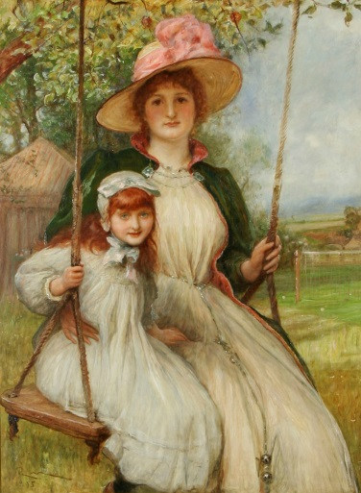

**Identity Clue 1 – Is the Daughter the Same as the Mother?**

Jeremiah 50:12; 50:42; 51:33 (+50:17 & 51:34)

**1.** Who else had a mother as a nation?

**2.** Did Babylon have a “mother” in scripture? Historically?

**3.** If God meant these clues to refer to ancient Babylon, why did He refer to it as the “Daughter of Babylon”?

**4.** Which nation will be ashamed when the DOB is destroyed?

Why will it be embarrassed?

**5.** Could these verses refer to the USA? Any other application?

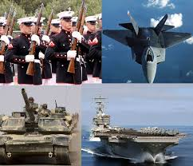

**Identity Clue 2** **– The Hammer of the Whole Earth**

Jeremiah 50:23; 51:20; Revelation 17:18; Matthew 24:32-35; Daniel 2

**1.** Could this be Stanley Tool Co.? They produce hammers worldwide. ☺

**2.** Which nation has the most military bases outside of its borders?

**3.** Which nation spends the most on military staff and armaments? On R&D?

**4.** Does any other nation come close to this title than the US?

**5.** Has the US used its hammer? Where? How often?

**6.** What is the meaning of the phrase “war club”? How has God used his war club in history?

**7.** Could these verses refer to the USA? Any other application?



**Identity Clue 3** **– A Latter Day Nation**

Jeremiah 50:12 KJV; Isaiah 2:2; Daniel 10:14

**1.** What is the meaning of the word translated as latter, hindermost or least?

**2.** Could this mean that the DOB is poor and disadvantaged? Why not?

**3.** Compared to other historic nations, how recent or new is the US?

**4.** Could these verses refer to the USA? Any other application?

**IV. Concluding Thoughts**

A jury is always instructed to avoid arriving at a final conclusion regarding the evidence until the jury hears all of the evidence. We’ve now looked at 3 identity clues. We’ll study 18 other identity clues in the lessons ahead, as well as 9 abomination identity clues. After this study, you should be able to decide if you think that the 30 Biblical clues as to the mystery of the identity of the Daughter of Babylon/Babylon the Great apply to America. If you conclude they do not, to what nation or institution they do apply? Be wary of deciding that the verses have no meaning or that they are to be ignored as irrelevant (“*All Scripture is God-breathed and is useful for teaching, rebuking, correcting and training in righteousness”* II Timothy 3:16) As you pray for wisdom consider this verse:

Prayerfully ask Him to reveal his meaning in these verses, for, *“If any of you lacks wisdom, he should ask God, who gives generously to all without finding fault, and it will be given to him”.* (James 1:5)

**LESSON THREE**

In our last lesson we covered Clues 1, 2 and 3 (Mother, Hammer and Hindermost). In this lesson, we’ll look at the following clues.



**Identity Clue 4** **– A Nation of Wealth and Luxury**

Jeremiah 50:11; 50:37; 51:13; Rev. 17:4; 18:3; 18:7; 18:9; 18:14; 18:16; 18:18

**1.** What percentage of the world’s population are Americans?

**2.** What percentage of the world’s GDP do Americans consume?

**3.** Looking at these two stats, do Americans consume more than our “fair share”? As viewed by other nations? As viewed by God?

**4.** Since the US is in a recession, does that effect your answer?

**5.** China’s economy is growing. Could it be the DOB? Why not?

**6.** The Catholic Church has many assets. Could this Clue apply to it?

**7.** Ancient Babylon is in ruins. Could this Clue apply to it?

**8.** Could this Clue refer to the USA? Any other application?

 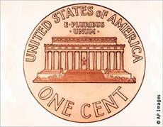

**Identity Clue 5 – A Multi-Ethnic ‘Melting Pot’ of a Nation**

Jeremiah 50:37

**1** Don’t all nations have immigrants?

**2.** What other nation has large numbers of non-native population?

**3.** How can we know that this clue can be narrowed to one nation?

**4.** Clue 13 is a large Jewish population. What other nations have attracted large numbers of Jewish residents throughout history?

**5.** Is this residence fact important in applying this clue to the US?

**6.** Clue 11 reveals the DOB as the location that the nations stream to meet. Is that a relevant fact in applying Clue 5 to the USA?

**7.** Other nations conquered Babylon over time. Does that make it a mingled people? Don’t the Bishops of the world gather in Rome?

**8.** Could this Clue refer to the USA? Any other application?

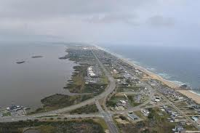

**Identity Clue 6** - **You Who Live on Many Waters**

Jeremiah 51:13; Rev. 17:1; 17:15; 18:17 and 19

**1.** Jeremiah 51:13 says that the Daughter of Babylon “Dwells upon many waters”. Revelation 17:1 tells us that Babylon the Great “sits on many waters”. Does this parallel description help in concluding that the two names refer to the same nation?

**2.** Does the US sit or dwell on many waters? Research the question. What % of the world’s fresh water lakes do we possess? How many coastal and inland ports do we have?

**3.** Could it be said that ancient Babylon lived on many waters? Does the Roman Catholic Church?

**4.** What does John say in Revelation 17:1 5 about the “waters” seen in the prophecy? Is this a dual application word in light of the other verses concerning ships, etc.?

**5.** Could this Clue refer to the USA? Any other application?

**LESSON FOUR**

In this lesson we’ll look at financial, political and entertainment clues to the identity of Mystery Babylon.



**Identity Clue 7** **– Center of World Commerce**

Rev. 18:11-13; 18:18; Isaiah 47:5; Jer. 50:18; 50:32; 51:43

**1.** Is it to be anticipated that a nation of great wealth, living in luxury, might also be a center of commerce? Which nations/cities have historically served as centers of commerce in their regions of the world?

**2.** Research the commodities that trade in the US. Do other nations have stock exchanges? If so, what is their importance in world commerce?

**3.** List a few of the commodities that primarily trade through US exhanges:

**4.** Could this Clue apply to ancient Babylon today? To the Catholic Church?

**5.** Could this Clue refer to the USA? Any other application?

**6.** While we are looking at this Clue, and focusing on New York City, look at the last verses above and arrive at a conclusion regarding whether the DOB/Babylon the Great is only one city, or instead, a nation of many cities.

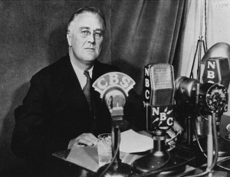

**Identity Clue 8** **- The Great Voice**

Jeremiah 51:55; 50:23; 50:38

**1.** Which nation is followed the most in the world’s media, outside the host country? Why?

**2.** Prior to Teddy Roosevelt was the US considered the Great Voice, or the Hammer of the Whole Earth, or the cultural center of the world? How about since Franklin Roosevelt? What happened between the two Presidents to change the perception of the US in the rest of the world?

**3.** Is any other nation a candidate for the title of The Great Voice?

**4.**  Is Iraq (site of ancient Babylon) a Great Voice?

**5.** Is the Roman Catholic Church the Great Voice, outside of its own member churches? What about in friendly Catholic nations? Does its voice control public affairs? Did it in Italy on the abortion issue?

**6.** Could this Clue refer to the USA? Any other application?

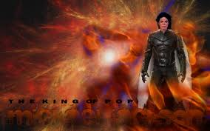

**Identity Clue 9** **– They Are Mad Upon Their Idols**

Jeremiah 50:38; 51:7; 51:47

**1.** What is an “idol” from a spiritual viewpoint? Does it have to be a “graven image”? What else can become an idol?

**2.** Could the producers of the television series come up with a better, more apt title than AMERICAN IDOL? How many Americans voted in the last season of the popular show? How many voted for President on November 6th? Do these two numbers convey any elemental truth about today’s Americans? What?

**3.** What happens to the idols? (Jer. 51:47)

**4.** The Catholic Church uses statues in their churches. Could the statues be the idols referred to in this Clue? Are there idols today in ancient Babylon?

**5.** What message about ourselves are we transmitting in movies and TV shows to the world’s billions? Are they “drinking of our wine” (Jer. 51:7)? What has been the effect?

**6.** Could this Clue refer to the USA? Any other application?

**LESSON FIVE**

Clues to the identity of Mystery Babylon this week include space travel, the United Nations and national pride.

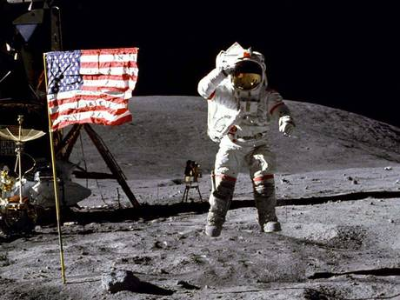

**Identity Clue 10** **– Mounts up to the Heavens**

Jeremiah 51:53

**1.** When Jeremiah wrote these words under the inspiration of the Holy Spirit, manned flight was 2,600 years away. Was he talking about “going to heaven, as in dying and….”?

**2.** If so, how does an entire nation ‘mount up to heaven’? The Hebrew word “alah” is translated as “mount up” (KJV), “reaches” (NIV) and “ascend to” (NAS). Do these translations leave any wiggle room for making the verse mean something else? If so, what?

**3.** If the Clue refers to launching men/machines into space, Russia was first with Sputnik in 1957. Eight other nations have since launched satellites into orbit (including China, EU, UK, Ukraine, Iran, Israel and India). Could any of these other nations be the DOB?

**4.** Has the US distinguished itself from these other nations in regard to ‘mounting up to the heavens’?

**5.** Did ancient Babylon do this?

**6.** Could this Clue refer to the USA? Any other application?

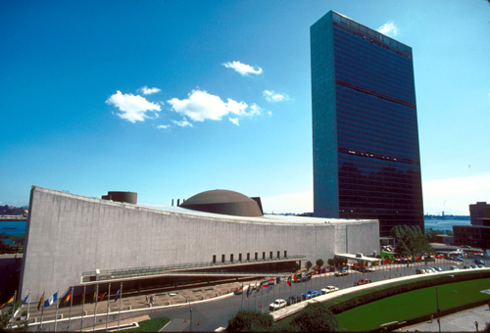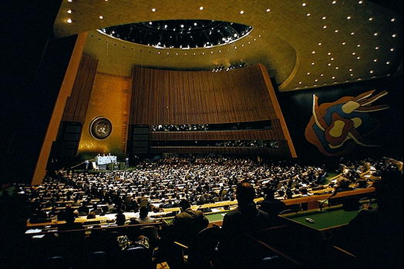

**Identity Clue 11 – Where the Nations Gather**

Jeremiah 51:44 (KJV and NAS); Genesis 11:1-9

**1.** How did the nations start?

**2.** Why did God separate the languages and form the nations?

**3.** Until modern times what has been the general course of inter-action between the nations of the world?

**4.** How many times have the world’s nations streamed together to meet on an organized basis? Where did they organize and meet? When?

**5.** What happened to the first effort in our times to unite the world? How successful has the current effort been?

**6.** Do the nations of the world stream to meet in Iraq?

**7.** Do the nations of the world stream to meet at Vatican City?

**8.** Could these verses refer to the USA? Any other application?

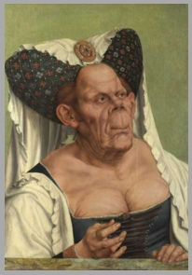

**Identity Clue 12** – **She Has Been Proud Against the Lord**

Jeremiah 50:29 (The Message), 31, 32; Heb. 11:8-10; Isaiah 47:5,7,8,10; (The Message) Rev. 18:7

**1.** Why do you think God chose to refer to the DOB/Babylon the Great as “The Queen of Kingdoms” instead of the “King of Kingdoms”?

**2.** Does this title have any relevance to the question of whether the DOB is a single large city or a nation of many cities?

**3.** How can *a nation* be “proud against the Lord”?

**4.** How does God view pride? In us? In a nation?

**5.** What leads the DOB to be full of arrogance and pride?

**6.** Can you think of any ways in which the US has:

*“shown arrogance and been dismissive, even derisive”*

*(President Obama 4/3/09 - Strasbourg, France)*

**7.** What is the cure for pride?

**8.** Could these verses refer to the USA? Any other application?

**LESSON SIX**

This lesson looks at identity clues for the Daughter of Babylon including Jewish population, deep water ports and Iran (Persia).

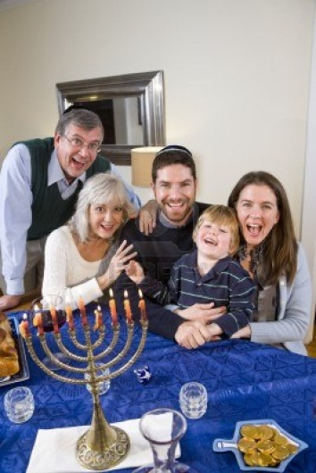

**Identity Clue 13** **– Jewish Population**

Jeremiah 50:4-5; Jeremiah 38:17; Rev 18:4; Zechariah 2:7; Isaiah 48:20

**1.** What is the Jewish population of the world?

**2.** What is the Jewish population of the US?

**3.** What other nations have large numbers of Jewish residents?

**4.** Did ancient Babylon have a high number of Jewish residents?

**5.** Does the Catholic Church have a large number of Jewish members?

**6.** When ancient Babylon was preparing to conquer Judah, what did God tell the King to do?

**7.** In Jeremiah 50:5 what does God tell the Jewish residents to do? Why the starkly different warnings?

**8.** Isaiah, Jeremiah and Zechariah warn Jewish residents of the DOB to flee. Do these warnings apply in the NT era? Isn’t God finished with Israel?

Where should the Jewish residents of the DOB flee? To Israel?

**9.** Could these verses refer to the USA? Any other application?

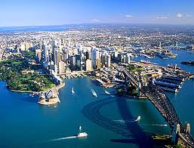

**Identity Clue 14** **– Deep Water Port Nation**

Revelation 18:17-19

**1.** Does the phrase “ships on the sea” tell us anything about the likelihood that the DOB has deep water sea ports?

**2.** If a nation is the center of world commerce is that consistent with this clue?

**3.** We’ve learned that the US has 400 inland and coastal deep water ports. What other nations of the world have large numbers of deep water ports?

**4.** Are any of them also candidates for DOB? Which?

**5.** Which clues clearly don’t apply to these nations?

**6.** Did ancient Babylon have a deep water port where the ships of the sea could sail? Does the Catholic Church?

**7.** Could these verses refer to the USA? Other possible applications?

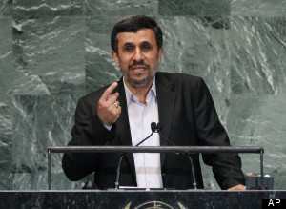 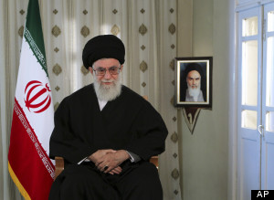

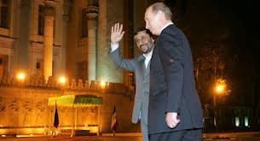

**Identity Clue 15** **- The Kings of the Medes Won’t Destroy Themselves**

Jeremiah 51:11, 27; Daniel 5:28; Esther 1:19; Ezekiel 38 & 39

**1.** Who were the Medes? In the 6th century, what areas of the world (described as modern nations) were under the control of the Median kingdom?

**2.** If the areas of modern day Iran and Iraq were under the Medes, why would God call up the Medes to destroy themselves?

**3.** For those who believe that the prophetic clues concerning the DOB/Babylon the Great were fulfilled in ancient Babylon, they may wish to ponder why the Medes would destroy themselves. God tells us in Jeremiah 51:11 that he will stir up the Kings of the Medes (see bas relief carvings on the wall above). Is Iran (Kings of Medes) a threat to world peace? How?

**4.** Ezekiel identifies the predecessor nation of modern day Russia, Gog of the land of Magog, as part of the invading force of Israel. Does Jeremiah, give us clues that the same people will be used to destroy the Daughter of Babylon/America in Jeremiah 51:27?

**5.** Where are *Ararat, Minni and Ashkenaz* located in today’s world?Ararat and Minni are today’s ____________, a former Republic of _________________. Ashkenaz was settled by descendants of ______________. Ashkenaz was ___________ first son. His descendants dwelt on the Eurasian Steppes, including western Russia.

**6.** Ezekiel in 38:6 lists Gomer as one of the nations that will join Russia for the Russian-Muslim invasion of Israel, in which the Daughter of Babylon is AWOL. Is there any significance to the prophecies that appear to disclose that the Medes (Persia/Iran) and Gomer (Russia) not only *invade Israel*, they *also* are part of the annihilation attack on the *Daughter of Babylon*. (Jeremiah 51:11 and 27)?

**7.** Could these verses refer to the USA? Any other application?

**LESSON SEVEN**

In Lesson Seven we’ll look at clues pointing to America as the Daughter of Babylon as the land of entertainment, the status of historical Babylon and America’s influence on the globe.

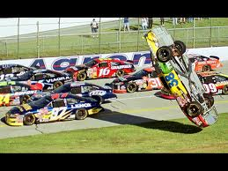

**Identity Clue 16 – A Land of Entertainment**

Revelation 18:22, 23; Jeremiah 50:2

**1.** How much do Americans spend annually to entertain ourselves?

**2.** Other nations entertain themselves, so how do we conclude that this clue most aptly applies to the US?

**3.** What is unique about American entertainment?

**4.** Is there anything inherently wrong with what America produces for entertainment?

**5.** How could American entertainment be seen as weaving a “magic spell”? How does that “magic spell” lead other nations astray?

**6.** What do you deduce from the bill that just passed Congress (purportedly to avoid the ‘fiscal cliff’) which gave tax breaks to Hollywood producers ($430M) and NASCAR track owners ($70M).

**7.** In Jeremiah 51:7 the Prophet tells us that the DOB had been a ‘golden cup’ in God’s hand, but now she has made the nations mad as they drink her wine. Could these words refer to what America produces for movies, TV, etc? Do other nations do this? Did ancient Babylon? Does the Catholic Church? Could these verses refer to the USA? Any other application?

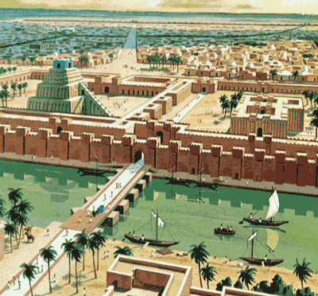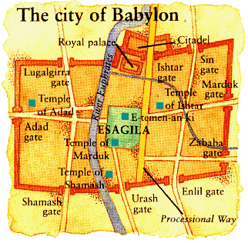

**Identity Clue 17** **– Historical Babylon is Gone and Won’t Be Back**

Genesis 10, 11:4; 11:9; Daniel 5; Revel. 18:9, 11

**1.** What is the genealogy from Noah to Nimrod, the founder of Babylon?

**2.** What was Nimrod’s/Babylonians’ construction goal?

**3.** Since Babylon means “Gate of God” why did He *divide* the languages/nations (Genesis 11:6-9) at that site? Why not let earthlings unite with one language, one religion, one leader, one world?

**4.** Is a New World Order/One World part of God’s plan for the world? If not, who is pushing the effort?

**5.** Hammurabi developed the world’s first legal code in 1700 BC (200 years before Moses). Nebuchadnezzar II built the hanging gardens making Babylon one of the Seven Wonders of the Ancient World. What is the current status of Babylon?

**6.** One Bible writer says that ancient Babylon will be re-built (from the heaps of ruin there now) and become the DOB/Babylon the Great as the world’s richest, most powerful, influential nation. What do you think? Do you see any Biblical flaws with this opinion?

**7.** Could these verses refer to the USA? Any other application?

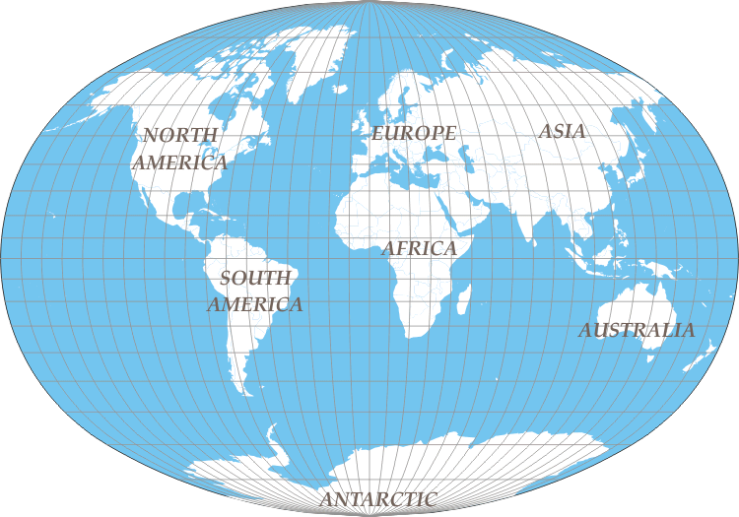

**Identity Clue 18 – Only America Sits on the 7 Continents of the Earth**

Revelation 17; Matthew 4:8

**1.** John describes Babylon the Great as riding on a beast with seven heads (Revelation 17:3). John then says “the seven heads are seven mountains, on which the woman sits” (17:9). Rev. Alexander Hislop in 1858 said this clue meant that the DOB/Babylon the Great was the Roman Catholic Church because it’s based in a city with seven hills. Do you see any problems with that view? How is the word used for “mountain” in this verse used in other scripture? (Mathew 4:8)

**2.** If the USA is the DOB/Babylon the Great can it be said that it rides on seven mountains? Seven continents?

**3.** Has any other nation/empire in the history of the world sat on all of the world’s continents at the same time?

**4.** What about the statement in the next verse (17:10) “and there are seven kings”?

**5.** Revelation 17:1 refers to this female figure of great power and influence as the “great whore”. Is that a harsh, even incorrect reference to the USA? Why? Why not?

**6.** Could these verses refer to the USA? Any other application?

**LESSON EIGHT**

In Lesson Eight we will study the last three of the twenty-one identity clues, before we turn to the Abomination Nation Clues.

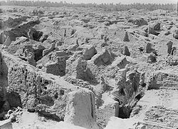 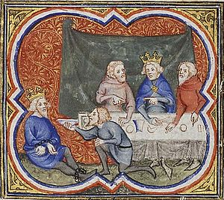 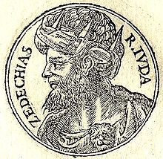

**Identity Clue 19** **– Has Ancient Babylon Already Been Punished?**

Jeremiah 21:5,6,7; 25:12; Isaiah 45:13

**1.** Judah’s King Zedekiah asked Jeremiah what would happen in the 18 month long seige being waged against Judah by Babylon under Nebuchadnezzar. First, what does this tell us about the spiritual maturity of Zedekiah? What about Jeremiah 52:2-3? Should national leaders ask for divine input? Isn’t that mixing church and state?

**2.** Zedekiah was appointed into office by the King of Babylon after he invaded Judah the first time. Zedekiah revolted against Babylon and made a treaty with Egypt against Babylon which led Babylon to return, invade, capture and destroy Judah. Jeremiah and others had warned against doing this. What do you think of a Prophet of God advising a country and its leaders to surrender to another nation?

**3.** Jeremiah was called a traitor. Was he?

**4.** Look at Jeremiah 25:12. What does God promise to do?

**5.** Did God keep His promise? Was his punishment immediate or over time? How much time?

**6.** Babylon was punished for what it did to Judah. Is it likely that Iraq (the site of ancient Babylon) will again be punished for the same sin committed in 589 to 517 BC?

**7.** What sin does the DOB/Babylon the Great commit against Israel according to prophecy? Could these verses refer to the USA? Any other application?

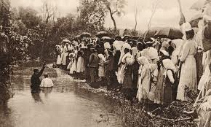 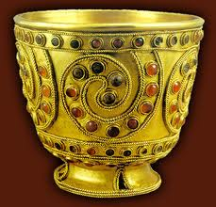

**Identity Clue 20** **– Past Spiritual Use of the Nation by God**

Jeremiah 51:7; Revelation 18:3

**1.** In one of Jeremiah’s DOB chapters he tells us that this future nation had a past. A past of being used by the hand of the Lord. His symbolism is as a “golden cup”. What do you think is meant by this symbolic reference?

**2.** Is Jeremiah 51:7 in the past, present or future tense?

**3.** What do you conclude from the verb tense?

**4.** Isn’t God still using the USA for missionary purposes?

**5.** John in Revelation 18:3 uses a similar symbolic reference for what can be consumed from a cup, i.e., “maddening wine of her adulteries”. What does this phrase mean?

**6.** How have the kings of the earth committed adultery with the DOB? How do the world’s nations commit adultery with each other?

**7.**  In what ways have the US poured out this maddening wine into the world?

**8.** Is it too late to stop doing it? Is the DOB destroyed because of these sins?

**9.** Could these verses refer to the USA? Other Possible Applications?

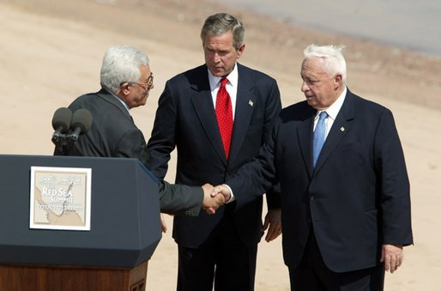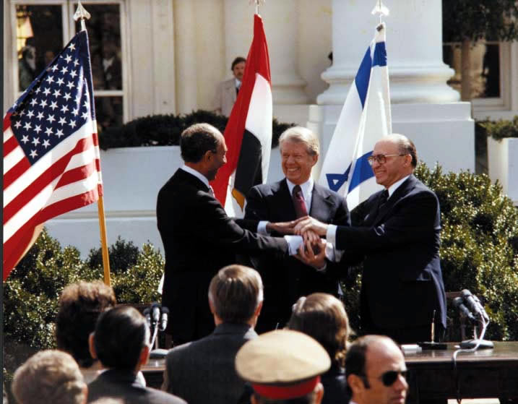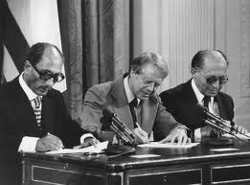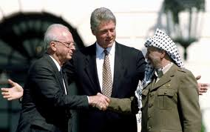

**Identity Clue 21** **– The Only Nation Sworn to Defend Israel**

Psalm 137:8; Isaiah 21:12; Jeremiah51:24; 35-36

**1.** God through His prophets explains *why* He is going to terminate the DOB. Is the reason the nation’s declining morals? As we saw in Clues 9, 12, 16, and 20, He is highly critical of such issues in this end times nation. So, is that why He ‘doomed it to destruction’?

**2.** What does He tell us is the reason?

**3.** What will the DOB do to Israel that will merit its own “repayment”?

**4.** How can a nation become a “traitor”?

**5.** Why will Israel need to be “avenged”?

**6.** How has the USA agreed to defend Israel? (March 26, 1979 Agreement – Attachment B to THE END OF AMERICA)

**7.** What about other agreements we have made with Israel? Under Clinton? Under either Bush? Under Obama? (See pages 99-101 in TEOA).

**8.** Name the other nations of the world that have made agreements with Israel. How has Egypt performed under its Camp David agreement?

**9.** What does God tell Israel about making treaties with other nations?

**10.** Could these verses refer to the USA? Any other application?

**LESSON NINE**

**(Chapter Seven – The End of America)**

**Prophecy’s Abomination Nation Clues**

Read Revelation 17:1’s description of Babylon the Great as *“the great whore”.* Could that harsh term apply to America? Read these verses which refer to DOB/Babylon the Great in unflattering terms. Consider if the nine ‘abomination nation’ clues can apply to other nations on the planet in the last days.

* Revelation 14:8
* Revelation 17:1, 4-5
* Revelation 18:2-3
* Revelation 19:2



***(My apologies for this picture, but after some searching it was the least offensive picture depicting abortion. In addition to which, as many in the pro-life movement have observed, if we can’t stand to look at the results of a practice, why do we allow it?)***

**Immorality Identity Clue A – ABORTION**

**1.** The phrase “Mother of Abominations of the Earth” (Rev.17:5) obviously implies that this nation births or brings forth abominations. Is there any sense in which America could be said to have mothered abortion?

**2.** Prior to Roe v. Wade in 1973 which nations allowed abortion and under what circumstances?

**3.** What is the current status of abortion in the world? Who allows it? Who prohibits abortion?

**4.** What does Isaiah 26:21 say God will do about innocent blood shed in other nations? Are they excused because they just followed the US lead?

**5.** How many abortions have been recorded since 1973? In the US? Globally?

**6.** What percentage of Americans conceived are aborted? In NYC?

**7.** What is God’s standard regarding the shedding of innocent blood? (Genesis 9:6)

**8.**  Can blood talk? (Genesis 4:10

**9.** If innocent blood is shed, what does it do to the land? (Numbers 35:33)

**10.** If a nation sheds innocent blood can it bring doom on itself? (Ezekiel 22:2-4)

**11.** Read Genesis 15:16 and Leviticus 18:21. What was the sin of the Amorites? What did Ezekiel say would happen to the people living in such a land? (18:24-28)

**12.** According to scripture, if a nation’s land is soaked with innocent blood, what is the only way to assuage God’s anger and atone for the shed blood? (Numbers 35:33)

Does this only apply to the abortion doctors? Explain

**13.** Is the church in America speaking out against America’s sin, particularly abortion?

**14.** Could this abomination clue apply to ancient Babylon?

Could it apply to the Catholic Church? Does it fit any other nation? Could this abomination clue apply to the US?

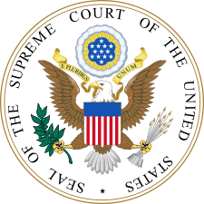

**Abomination Nation Clue B** **- Pornography**

In the history of mankind, there has, of course, been natural interest in sexual matters. The Song of Solomon describes a healthy ‘act of marriage’ physical relationship. Romans 1:18-32 warns us about the downward slippery slope of sexual sin. What does Paul say *starts* the downward fall?

Where does it end?

Until the 20th Century England and America (followed by most of the world) prohibited the publication, distribution and ownership of “obscene materials”. 1857 the British Parliament adopted the Obscene Publications Act. The court held that all material tending "to deprave and corrupt those whose minds are open to such immoral influences" was obscene, regardless of its artistic or literary merit.

In 1873 Anthony Comstock led a crusade in the United States to ban obscenity. After passage of the Comstock Act he was appointed as a postal inspector to enforce the new law. Eventually all states prohibited pornographic or obscene materials. In 1896 The U. S. Supreme Court adopted the British *Hicklin* test in [*Rosen v. United States*](http://en.wikipedia.org/wiki/Rosen_v._United_States), as the legal test for obscenity in the US. .That all changed in 1957 when the U.S. Supreme Court in *Roth v. United States* ruled that"all ideas having even the slightest redeeming social importance [...] have the full protection of guaranties [sic]". In 1964 the Supreme Court opened the door to wide availability in America of obscene materials. Justice Potter Stewart wrote that virtually every form of obscenity is legal except for “hard core pornography”. Justice Stewart declined to define what that phrase meant, saying “I know it when I see it”. By 1973 in the famous *Miller* case there were very few restrictions left on obscene materials as long as it has any “literary, artistic, political or scientific value”. In 1973 the U. S. Supreme Court ruled that the Federal Communications Commission could not regulate cable television, but could do so for network TV during hours that children could be watching. In January of this year the Court heard arguments by networks that since cable and the internet can broadcast nudity and obscene language and material, that the networks should be allowed to do the same. It is expected that the Supreme Court will remove this last barrier to widespread obscene broadcast material available to all ages at all hours.

1. This abomination nation clue arises from John’s several references in Revelation 14, 18 and 19 to Babylon the Great providing to the world “maddening wine of her adulteries”, “abominable things and filth” and “who corrupted the earth by her adulteries”. Besides what the US produces in its movies and television, how else could this clue be applicable to America?
2. Which nation is the world’s leading producer and distributor of pornographic material?
3. How much pornographic material is produced & distributed?
4. How does that compare with other nations?
5. Is pornographic viewing restricted to unbelievers? Effect on the Church?
6. Does pornography use have any impact on marriages? Divorces?
7. Jihadists criticize America for its “immorality”. Do they have a point?
8. Could this clue apply to ancient Babylon?
9. To the Catholic Church?

**10**. To other nations of the world? Can any other nation to which it could apply?

***Immorality Identity Clue C – Adultery & Divorce***

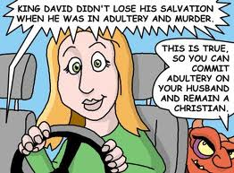

1. Scripture decries adultery. Adultery is mentioned 45 times in the NIV. What is adultery?
2. What is God’s view of adultery? (Exodus 20:14, etc.)
3. Are there any spiritual aspects of adultery?
4. How does adultery affect God’s plan for mankind?
5. God refers to Babylon the Great 5 times as being the source of adulteries:

Revelation 14:8 - “…maddening wine of her adulteries…”

Revelation 17:1, 4-5 – “…filled with abominable things and filth of her adulteries…”

Revelation 18:2-3 – “…all the nations have drunk of the maddening wine of her adulteries…”

Revelation 18:9 – “…the kings of the earth who committed adultery with her and shared her luxury…”

Revelation 19:2 – “…who corrupted the earth by her adulteries…”

In what ways could the *United States* have been the source of “adulteries” spread across the world? Could the clue apply to other nations?

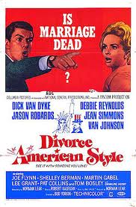 

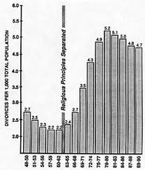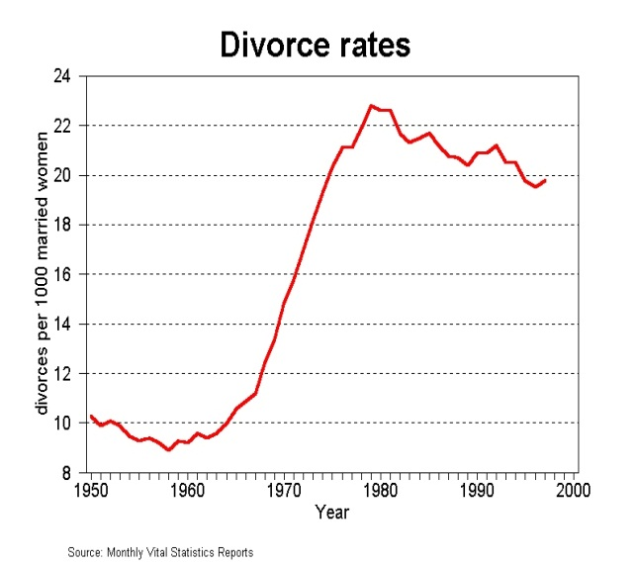

1. Scripture decries divorce. Divorce is mentioned 33 times in the NIV. What is divorce?
2. What is God’s view of divorce?
3. Are there any spiritual aspects of divorce?
4. How does divorce affect God’s plan for mankind?
5. What is the impact of divorce on children? Can the view of God and His Son by children of divorce be affected by the change in the family?
6. In what manner could it be said that the *United States* had a leading role in ‘mothering’ divorce? Did Great Britain, the ‘Mother of the US, have ant role in this change? Could the clue apply to other nations?

**LESSON TEN**

**(Continuing in Chapter Seven of TEOA)**

In Lesson Nine we looked at Abomination Nation Clues regarding Abortion, Pornography and Adultery/Divorce. In this lesson we’ll look at three more such clues.

***Immorality Identity Clue D – Same Sex Marriage***



1. Where did the concept of marriage between a man and a woman originate? (Genesis 2:23-24)
2. The word “marriage” is used early in scripture (Genesis 34:9). Where in scripture does God dramatically show His approval of marriage? (John 2:1-12)
3. What did God do to Sodom (Genesis 19)? Why? Is God ‘homophobic’?
4. Does God love all people? Why not allow all people to marry? What are the spiritual implications of the marriage relationship?
5. What was the effect of the destruction of Sodom and Gomorrah on the world’s laws and behavior for 3,500 years?
6. What has been the role of the *United States* in promoting same sex marriage to the world? Prior to 2003 what did the US Supreme Court hold concerning the states’ laws criminalizing sodomy?

1. What did the US Supreme Court change in the laws of the states in 2003 in *Lawrence v. Texas?* What did Justice Scalia predict from the bench would happen as a result of the case?
2. Prior to this case was same sex marriage discussed in America?
3. In the last ten years what has occurred regarding same sex marriage? Which states today allow same sex marriage?
4. What effect has this case (and what has occurred since the case was decided) had on the nations of the world? (What is France doing this month?)
5. What did Jesus say that the last days would be like? (Luke 17:26-30)
6. Are these days like the days of Lot? In what ways?
7. Could this abomination clue apply to any other nation? Church?

***Immorality Identity Clue E - Violence***

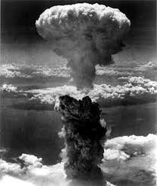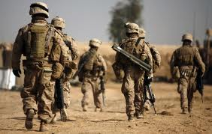 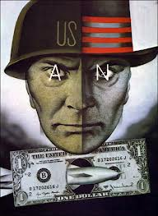

This clue is a difficult one for Americans to discuss. Any citizen of a nation cheers for it to succeed, whether in war or in the hockey rink. USA, USA, USA. To follow the sports analogy, a fan of a sports team who is critical of his or her own team is not considered to be normal. For purposes of the discussion of this abomination clue, set yourself aside from the nation, as much as possible, and look at it in a detached, dispassionate manner.

The Bible is replete with examples of violence. The world’s first family experienced a family murder, with Cain killing Abel (Genesis 4:8). Sixty six books later (after describing a myriad of killings, battles and wars) the Bible ends (before the return of Christ, the millenium, etc.) prophesying the worst war in world history, with every (remaining) nation fighting against God and Israel (Revelation 19). Since there is so much violence in scripture let’s attempt to arrive at a conclusion as to God’s view of violence?

1. God selected David to be King over Israel. An enemy of David referred to him as “a man of blood”, a term which David said God had allowed the enemy to say (II Samuel 16:8). In II Samuel 22 David praises God for training him and equipping him to be a warrior and to fight battles. David fought many battles, including one in which he killed 40,000 (II Samuel 11). What did God tell David towards the end of his life about the violence in which he had been involved? (I Chronicles 22:8). What was Solomon’s view of this issue? (I Kings 5:1-3)
2. What do you conclude about a righteous war versus wanton violence and unneeded bloodshed? Did He encourage Israel to fight wars? Why did He say the enemies to be destroyed needed to be conquered? Is it ‘*our country, right or wrong’*?
3. Can bloodshed be justified? In what instances (Exoidus 22:2)What do you think the Biblical standard is for bearing arms? (Luke 22:49). Were the disciples of Jesus armed? Should Christians be pacifists?
4. America’s Jihadist enemies attack our nation claiming that we are an arrogant and violent people, accusing us of launching cruise missiles at random and killing civilians, including women and children. Osama bin Laden told the world that it should read an American book entitled *Rogue State*. The book lists seventy (70) American military and intelligence agency invasions/interventions in the world since 1945 (listed on pages 141-2 of TEOA). Do our critics have any legitimacy to their claims?
5. On March 26, 2003 America launched an invasion against Iraq, without declaring war. The war lasted until December, 2011. 24,219 were killed and 117,961 were wounded on the coalition side. Between 28,000 and 37,000 troops were killed on the Iraqi side. Between 103,000 and 113,000 civilians died in the war in Iraq. The stated justification for America to invade Iraq was that it had possesion of weapons of mass destruction, which were never located after the invasion nor during the war. It was determined that Iraq had stopped any development of WMDs in 1991. Another justification for the invasion was that Saddam Hussein was harboring al Qaeda agents, but after the invasion this charge was never confirmed. These undisputed facts raise a number of questions: A.) Should a nation invade another soverign nation based on that nation’s purported possession of weapons? B.) If so, could the US have invaded, or could it invade, Rusia, or Pakistan, or North Korea or France due to their possesion of WMDs? C.) Did our invasion of Iraq fall under the description of Babylon the Great: *“In her was found the blood of prophets and of God’s holy people, of all who have been slaughtered on the earth.”*

1. In 1941 Japan secretly invaded Pearl Harbor and killed 3,300 persons, mostly members of the military. In three and a half years of war the US suffered about 100,000 killed or missing in the Pacific theater. In August, 1945 America detonated two atomic bombs over Japan, killing an estimated 220,000 casualties, including civilian women and children. U. S. Secretary of War Henry Stimson concluded before the detonation of American nuclear weapons, that Japan was about to surrender. He based his conclusion on the fact that America had in 1945 firebombed 67 Japanese cities, resulting in widespread civilian deaths and crippling the Japanese economy. Proponents of the nuking of Japan argued that the Japanese would never surrender. Color movies which were taken of the cities of Hiroshima and Nagasaki were censored and only recently released. How do you react to being a resident of the world’s only nation ever to use nuclear weapons in war? Did our killing of over 200,000 civilians in Japan fall under the description of Babylon the Great: *“In her was found the blood of prophets and of God’s holy people, of all who have been slaughtered on the earth.”*
2. Could the abomination clue of violence apply to any other nation?

To the US?

***Immorality Identity Clue F – Drug Culture***

 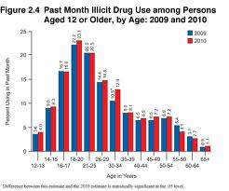

1. In our prior ‘Mother of the Earth’s Abominations’ clues we have looked at what America exports (funding to change abortion laws, pornography, entertainment promoting adultery and divorce, court rulings favoring same sex marriage, etc.). In this clue we look at what America consumes as an abomination. Look at the following two quotes:
2. *“If there were not so many consumers in the United States, then we would not produce so many drugs. We are simply supplying a product where there is a demand. It is as simple as the law of supply and demand! Your average campesino is only trying to make a living the best way he can. They do not use or consume drugs themselves after all.* *The sad fact of the matter is that too many Latin Americans, because of lack of education and underdeveloped Third World economies, have nothing better (or more profitable) to do with their time and industry than to produce and smuggle illicit drugs. And the United States has the temerity to blame the Latin Americans for their own huge drug appetite! Everyone in the United States has been told that drugs are dangerous and yet people still buy and consume them to the tune of an estimated 57.3 billion dollars in 1995!*
3. The 2009 CIA Factbook reports:

*“The United States is the world’s largest consumer of cocaine, Colombian heroin, and Mexican heroin and marijuana; major consumer of ecstasy and Mexican methamphetamine; minor consumer of high-quality Southeast Asian heroin; illicit producer of cannabis, marijuana, depressants, …hallucinogens, and methamphetamine.”*

1. Read Galations 5:20; Revelation 9:21, 18:23; 21:8; 22:15. The original Greek word used was “pharmakeia” φαρμακεια, the practice of making medications, elixirs or potions. Our word “pharmacy” is derived from the greek word. Some versions translate it as “sorceries” (next week we will look at the “witchcraft” clue), but some give it the translation of “spells and drugs” (CEB). What is God’s view of excessive or harmful use of medications? Why might He have such a view?
2. Besides being the world’s largest market and consumer of illicit drugs, in what sense could America be seen as a ‘leader’ in promoting a.) illicit drug use and b.) prescription drug abuse?
3. What does the US do to encourage the people of other nations to consume illicit drugs or misuse prescription drugs?
4. Since America has developed so many healing medicines over the decades, shouldn’t we get a pass on this criticism? After all, can we help it if others misuse what we developed?
5. What is the estimated drug use of young Americans between the ages of 16-25? Does the high level of illicit drug use by younger Americans indicate anything about our future?
6. Many, including some ‘conservatives’, are advocating the legalization of certain illicit/illegal drugs? Do they have a point? Is their position Biblical? Do you see any implications of the “Mother of Abominations” charge if the US changes its laws? Will it likely affect how the world thinks/legislates on this issue?
7. Could this abomination clue apply to any other nation? To the U.S.?

**LESSON ELEVEN**

**(Continuing in Chapter Seven of TEOA)**

**Abomination Nation Clues G, H & I**

God provided us thirty clues to the identity of Mystery Babylon from five Prophets. We have now studied in depth Clues 1-21, the identity clues. With this lesson we will conclude the nine Abomination Nation clues.

***Immorality Identity Clue G – Witchcraft***

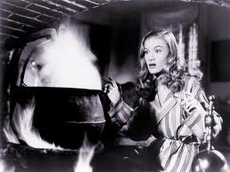 

## Frank Sinatra Witchcraft Lyrics

[**Send "Witchcraft" Ringtone to your Cell**](http://www.ultimate-guitar.com/xtra/clktr.php?ug_from=tabs&url=http://www.ringtonematcher.com/co/ringtonematcher/02/noc.asp?sid=NOLFros&artist=frank+sinatra&song=witchcraft&campaign=lf)

Songwriters: CY COLEMAN, CAROLYN LEIGH

Those fingers in my hair, That sly come hither stare, That strips my conscience bare, **It’s witchcraft**  
And I’ve got no defense for it, The heat is too intense for it, What good would common sense for it do  
**Cause it's witchcraft, wicked witchcraft**, And although, I know, **it's strictly** **taboo**, When you arouse the need in me, My heart says yes indeed in me, **Proceed with what your leading me to**,

**It’s such an ancient pitch, But one I wouldn't switch**, Cause there's no nicer **witch** than you.

**1.** It’s not inconsequential that when God chose *a name* for the rich, powerful, influential end times nation that he shrouded in 30 Mystery Clues, He selected BABYLON. (Babylon the Great, the Daughter of Babylon, Mystery Babylon). “Babylon was the birthplace of astrology from which sprung the twelve-fold division of the day, the horoscope and sun-dial; but it was also the home of magic, which pretended to bind the course of events." (The Practice of Witchcraft in the Scriptures, Dallas Theological Seminary, *Bibliotheca Sacra*) Does the Bible refer to the occult, witchcraft, sorceries, divination, astrology, secret arts, etc.? What do you find as you search scripture?

**2.** Nimrod, Noah’s grandson, is credited with initiating many aspects of witchcraft. He first appears in the Bible in Genesis 10:8. We find “magicians” referred to as early as Genesis 41:8, 24, called in by Pharaoh to interpret his dreams. When Moses appeared to set God’s people free and called down plagues on Egypt, Pharaoh’s magicians duplicated three of the plagues (rods to snakes – Exodus 7:12; water to blood 7:22 and frogs 8:7). All three with accompanied by “their enchantments”. What does that mean? Were the magicians able to duplicate further plagues? Why did God allow them to duplicate these plagues? What do we learn about satan’s power and that of his followers from these scriptural recitations of past magical acts?

**3.** What is God’s view of witchcraft? (1 Sam 15:23)

**4.** Scripture tells us that“rebellion [is as] the sin of witchcraft”. In what way are they similar?

**5.** For a lengthy list of occultic sins let’s look at one of Judah’s kings:

### 2 Chronicles 33

King James Version (KJV)

*1**Manasseh was twelve years old when he began to reign, and he reigned fifty and five years in Jerusalem:* ***2****But did that which was evil in the sight of the Lord, like unto the abominations of the heathen, whom the Lord had cast out before the children of Israel.* ***3****For he built again the high places which Hezekiah his father had broken down, and he reared up altars for Baalim, and made groves, and worshipped all the host of heaven, and served them.* ***4****Also he built altars in the house of the Lord, whereof the Lord had said, In Jerusalem shall my name be forever.* ***5****And he built altars for all the host of heaven in the two courts of the house of the Lord.* ***6****And he caused his children to pass through the fire in the valley of the son of Hinnom: also he observed times, and used enchantments, and used witchcraft, and dealt with a familiar spirit, and with wizards: he wrought much evil in the sight of the Lord, to provoke him to anger.*

What did King Manasseh receive as punishment for his theological errors and evil practices?

**6.** In each of Paul’s missionary journeys he encountered satanic occultic powers. At Ephesus Christians confessed to previous occultic practices, burning their magic books (Acts 19:19). In Revelation 9:20 we learn that earthlings not killed by the trumpet judgments will continue in their sorceries. Do these New Testament references to witchcraft tell us anything about the role of the occult today?

**7.** Are Americans who are involved in sorcery, witchcraft, etc. engaging in sin or are these activities just harmless fun?

What is your view of Christians watching movies and television shows about zombies, demons, vampires or a bespectacled Harry Potter? What about visiting theme parks with attractions centered on wizards, demons and enchantments? Should young children be allowed to read books based on occult themes?

**8.** In what way could America be a “mother” of the abomination of witchcraft? Could this abomination clue apply to any other nation?

***Immorality Identity Clue H – Sumptuous, Self-Indulgent Lifestyles***



*“You who live by many waters and are rich in treasures…”* (Jeremiah 51:13)

*“…the merchants of the earth grew rich from her excessive luxuries”* (Revelation 18:3)

*“Give her as much torture and grief as the glory and luxury she gave herself.”* Revelation 18:7

**1.** What is God’s view of riches? What did Jesus say to the rich young man? (Luke 18:18-30) Did Jesus mean that wealth prohibited one from salvation?

**2.** Since God provides everything we have, what are we to make of those who are rich, living in luxury? Are they blessed by God, or cursed? Why?

**3.** Revelation 18 shows the merchants of the earth weeping and wailing when Babylon the Great is destroyed, listing the many earthly goods and products that will be affected when the world’s leading consumer is no longer consuming. If the US is no longer buying the world’s goods, what will be the impact on the world’s (remaining) economy? How will this play into the plans of Jihadists to conquer the world for Allahand for the Anti-Christ and the false prophet?

**4.** America has under 5% of the world’s population and consumes about 25% of the world’s energy, goods and services. In what ways could it be said that Americans are committing an abomination by our sumptuous, self-indulgent lifestyles? What has been the effect on the people of the world?

**5.** But, what about our missionary work? What percentage of US GDP is expended on missionary efforts?

**6.** What is the role of American advertising on Americans? On the world’s people? Is there anything wrong with advertising, as we see/hear it today?

**7.** Could this abomination clue apply to any other nation? To the US?

***Immorality Identity Clue I – Other Abominations***

Israelites were criticized in Judges 2:17 for prostituting themselves to “other gods”:

*“But they did not obey their leaders. Instead they prostituted themselves to other gods and worshiped them. They quickly turned aside from the path their ancestors had walked. Their ancestors had obeyed the Lord’s commands, but they did not.*

What other ways do you see that show that Americans have prostituted ourselves to “other gods”? For what other abominations is our country responsible? (A starter example – what effect has America’s promotion of the ‘prosperity gospel’ been on the world as an abomination?) As you list these, consider if any other nation could be said to the source of the listed abomination? To ancient Babylon?

**LESSON TWELVE**

**(Chapter Six of TEOA)**

**Events that Will Occur in Babylon *Before* its Fall**

We have now studied in depth the thirty clues that God gave us through five of His Prophets to help His people identify the identity of MYSTERY BABYLON. Twenty-one were identity clues and nine were abomination nation clues. Each clue squarely applied to the United States. A few could be interpreted to apply to other nations or entities, e.g., the Roman Catholic Church is headquartered in a city with seven hills (though the original Hebrew word is for a ‘high mountain’, not a hill). The RCC also has a history of mixing sorcery in its activities. No other nation has more than one or two clues, e.g., several nations have many seaports. Any fair application and interpretation of the thirty clues results in the conclusion that the United States appears to be Mystery Babylon, the Daughter of Babylon, Babylon the Great. Prophecies concerning Mystery Babylon tell us more than just the *identity* of the rich, powerful and influential end times nation. These Old and New Testament prophecies also reveal to us *several events* *that will* *occur prior to the final destruction of Mystery Babylon*. Let’s study those prophesied events.

**1. God Turns Over His People to the Daughter of Babylon**



*“1. Fall down! Sit in the dirt,  
O virgin daughter Babylon!  
Sit on the ground, not on a throne,  
O daughter of the Babylonians!  
Indeed, you will no longer be called delicate and pampered.*

*6. I was angry at my people;  
I defiled my special possession  
and handed them over to you.  
You showed them no mercy;  
you even placed a very heavy burden on old people.”*

Isaiah 47:1 and 6.

**1.** Assuming that the United States of America is the Daughter of Babylon (see Lessons 3-14), the nation with whom Isaiah prophesies God becomes angry is our nation. List the first three reasons that spring to your mind as to why the God of the Universe would become angry with His people who live in the Daughter of Babylon.

**2.** Isaiah’s prophecies are written and addressed to the Daughter of Babylon, God using the personal pronoun “you” when addressing the nation. He says that He “handed *them* over to *you*” and “*you* showed them no mercy”. The “*you*” refers to the government of the Daughter of Babylon, as nations act through their governments. “*Them*” refers to “*My* people” and “*My* special possession”. Can you think of ways in which a sovereign God could “*hand over*” “*His people*” to the government of their nation?

**3.** In the Bible did God ever “*turn over*” the Israelites to a government (hint – look at the evil kings of Israel and Judah and how their people reacted to their evil, along with their subsequent treatment by God based on their reaction to evil leadership) or other nation? Does God care who Christians vote for in elections for public office? How about Christian leaders, pastors, etc.?

**4.** Since there are millions of faithful, spirit-filled, solid Christians living in America/Daughter of Babylon, is it fair that they are included in *God’s people* *handed over* to the government of the Daughter of Babylon? What provision has God made/will make regarding such people?

**5.** What do you make of the very specific prophecy that the government of the Daughter of Babylon *“even placed a very heavy burden on old people.”* Can you think of anything that has occurred in the last few years pointing towards the fulfillment of this prophecy? What about the future? Why do you think God specifically identified this one demographic group as the subject of a “*very heavy burden*”?

**6.** What do you think the word “defiled” means in regard to God’s “special possession” in verse 6? Here God states that *He* will be the entity responsible for the defilement, not the government. In what ways has God in the Bible and in world history “*defiled*” “*His people*”, “*His special possession*”? If He would defile Israel, do we have a special pass to avoid defilement as Christians?

**7.** Is the “*turn over*” irreversible? Can God’s people escape being treated without mercy? Avoid defilement? If so, how? If so, when? How long does God say He waits until he “turns over” His people?

**2. Strangers in the Sanctuaries**

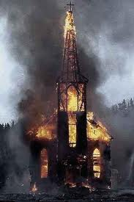 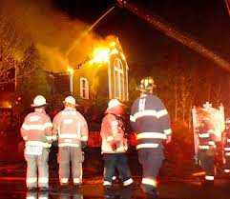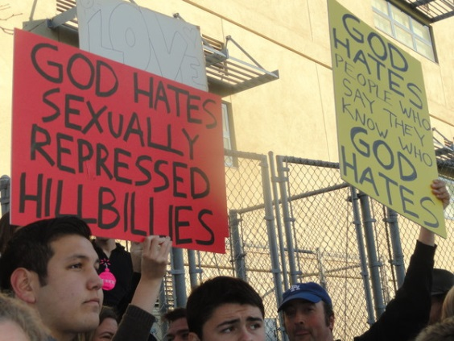

***“****For thus saith the* *Lord* *of hosts, the God of Israel; the daughter of Babylon is like a threshing floor, it is time to thresh her: yet a little while, and the time of her harvest shall come.”*

*“We are confounded, because we have heard reproach: shame hath covered our faces: for strangers are come into the sanctuaries of the Lord's house.”*

Jeremiah 51:33 and 51 (KJV)

### Attack on Mt. Hope Church in Lansing, MI

While a contingent from Bash Back's Lansing chapter picketed outside Mount Hope Church on November 9, 2008, several Bash Back! members entered the building disguised in plain-clothes and interrupted a worship service at the [large church](http://en.wikipedia.org/wiki/Megachurch)  in  [Lansing, MI](http://en.wikipedia.org/wiki/Lansing,_MI). During the late morning service the group dropped a rainbow banner bearing the slogan "It's Okay to Be Gay! Bash Back!" from the sanctuary balcony and showered a thousand fliers exhorting teenagers in the congregation to "embrace and explore" their feelings and assuring them there are many organizations supportive of gays that "enable you to be who you truly are." According to *Bash Back! News*, Mount Hope Church was targeted for its [fundamentalist](http://en.wikipedia.org/wiki/Fundamentalist_Christianity) belief that homosexuality is a sin, for its production of "[hell houses](http://en.wikipedia.org/wiki/Hell_house)" that demonize gays, and for its hosting of conferences of "ex-gays".

**1.** Some translations interpret the people who will enter God’s sanctuaries as “*strangers*”, other as “*foreigners*” or “*aliens*”. Since most churches are open to anyone who wishes to attend, what do you perceive God meant when He gave these prophecies to Jeremiah?

**2.** Former Governor Sarah Palin’s Baptist Church in Wasilla, Alaska was set on fire, with people inside, resulting in $1 million in damages:

From the [Anchorage Daily News](http://www.adn.com/news/alaska/matsu/story/621988.html):  
  
Fire officials are investigating a suspicious blaze at one of the biggest churches in the Matanuska-Susitna Borough. The pastor is estimating damage at more than $1 million. No one was injured in the fire at the Wasilla Bible Church, which started late Friday. About a half dozen church members were in the building doing crafts when the fire began but were able to get out safely after the building's fire alarm sounded, pastor Larry Kroon said. The church, located off the Parks Highway on the north end of town, is one of the biggest in the Valley with a typical Sunday service drawing up to a 1,000 people.  
Several well-known Valley residents attend the church, including Gov. Sarah Palin and Rep. Wes Keller, R-Wasilla.

Many churches and synagogues have been burnt or defaced in America in the last few years. Do you see these incidents as partial fulfillment of Jeremiah’s prophecies? Was Jeremiah, in your opinion, referring to more serious incidents than these fires?

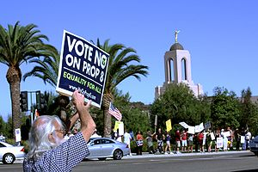

**3.** Proposition 8 was a ballot initiative in California in which the voters of the state, a majority vote, enacted a law stating that marriage was exclusively between a man and a woman. Many religious groups and churches were involved in the 2008 vote, but the Mormon Church (LDS) was most prominent. Soon after the votes were counted, hundreds, and then many thousands of protestors surrounded Mormon Temples in California and a week later in Salt Lake City, Utah. Vandalism was widespread. The following Saturday protests were organized in all fifty states with an estimated total of one million persons protesting church involvement in opposing Prop 8. One media columnist wrote that “protests, bomb threats and marches” against the church were justified. Does the government have any obligation to protect people of faith from attacks on their facilities and on those who attend churches, temples and synagogues which preach the Biblical view of marriage? Since the government has filed briefs with the U S Supreme Court urging that Prop 8 be thrown out as unconstitutional does that fact make it more or less likely that it will seek to protect people of faith? Is it possible that people of faith could be singled out by the government if the Supreme Court holds that there is a Constitutional right to same sex marriage?

**4** Jeremiah reveals in 51:51 that God’s people will say “*we are* *confounded*, *because we have heard reproach*: *shame hath covered our faces*”. What do these prophecies mean? Could the “*reproach*” be from the government? From other Americans generally? From fellow Christians or pastors? Who is likely to “*reproach*” God’s people when “*strangers*” come into God’s “*sanctuaries*”?

**5.** Let’s do a hypothetical. Say that the U. S. Supreme Court rules on the Prop 8 appeal that the US Constitution’s equal protection clause in the 14th Amendment (adopted after the Civil War) somehow includes the rule of law that same sex marriage may not be prohibited by law (as 32 states have done). If the U.S. Congress or the legislature of your state passes a law providing that speaking against same sex marriage is “hate speech”, will you change your views on the subject and become a supporter of same sex marriage? If your pastor asks your church board if he should oppose the law and give sermons based on the Biblical view of marriage, how would you vote if you were on the church board? What if your vote meant you could be jailed?

**6.** If America is the Daughter of Babylon, have the nation’s churches done anything that would lead to strangers invading its sanctuaries?

**7.** If America is the Daughter of Babylon, have the nation’s churches *not* done something that would lead to strangers invading its sanctuaries?

**Event 3 - Israel Will Be At Peace**

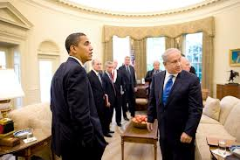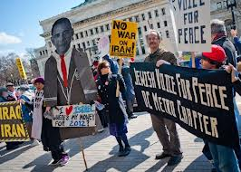

Jeremiah prophesies that “*Babylon must fall for the slain of Israel*” (51:49) and quotes “*the inhabitants of Zion*” as crying out “*May the violence done to our flesh be upon Babylon*…*May our blood be on those who live in Babylonia*.” How will that happen? How is the blood of Israel shed? Ezekiel prophesies that in “*the latter years*” (38:8) an invasion of Israel will occur. Ezekiel names the invading nations (Russia, Iran, Libya, et al). We’ll study what the Bible says about Israel at Peace in the latter years.

**1.** God scattered Israel “*among the nations”* (Ezekiel 36:19) for almost nineteen centuries, from the fall of Jerusalem in 70 AD until 1948. But, He prophesied that Israel “*were soon to come home*” (36:8). Do you think that the formation of present Israel on May 14, 1948 is a fulfillment of these prophecies, or is current Israel not the fulfillment? Is it just another nation, as some Christians believe?

**2.**  For all those centuries Jewish expatriates in exile had only God’s promises of return upon which to rely, such as:*And I will multiply people on you, the whole house of Israel, all of it. The cities shall be inhabited and the waste places rebuilt.**And I will multiply on you man and beast, and they shall multiply and be fruitful. And I will cause you to be inhabited as in your former times, and will do more good to you than ever before.* (Ezekiel 36:10-11). Looking at Israel today, have these prophecies been fulfilled?

**3.** In 38:8Ezekiel writes: “*In the latter years you will go against the land that is restored from war, the land whose people were gathered from many peoples upon the mountains of Israel, which had been a continual waste. Its people were brought out from the peoples and now dwell securely, all of them.”*Which portions apply to Israel today - in 2013? Which don’t?

**4.** Read the following verses:

*“Thus says the Lord God: On that day, thoughts will come into your mind, and you will devise an evil scheme****11****and say, ‘I will go up against the land of unwalled villages. I will fall upon the quiet people who dwell securely, all of them dwelling without walls, and having no bars or gates’* (Ezekiel 38:10 & 11)

*“Therefore, son of man, prophesy, and say to Gog, Thus says the Lord God: On that day when my people Israel are dwelling securely, will you not know it?* (Ezekiel 38:14)

*They shall forget their shame and all the treachery they have practiced against me, when they dwell securely in their land with none to make them afraid,****27****when I have brought them back from the peoples and gathered them from their enemies' lands, and through them have vindicated my holiness in the sight of many nations.* (Ezekiel 39:26 & 27)

What do you conclude from these verses? Is there any doubt that Israel will enter into a peace agreement?

**5.** The President of the United States is making his first visit to Israel on March 20th. Presidents Bush (twice), Clinton and Obama have all pressured Israel, quite publically, to give up “land for peace”. An example:

*“The United States believes that negotiations should result in two states, with permanent Palestinian borders with Israel, Jordan, and Egypt, and a permanent Israeli border with Palestine. We believe the borders of Israel and Palestine should be based on the 1967 lines with mutually agreed swaps, so that recognized borders are established for both states. Palestinian people must have the right to govern themselves and reach their potential, in a sovereign and contiguous state.”***-U S President Barack Obama** (emphasis added)

What is God’s position on Israel giving up its (His) land? (Genesis 13:14-17; Ezekiel 37:11-14; 38:13; Hebrews 11:8-10)

**6.** What is God’s view of Israel entering into peace treaties with other nations? (Exodus 23:32; II Kings 18:21). In light of Genesis 12:3, do you think that America will be blessed for forcing Israel to give up land that God says not to give up?

**LESSON THIRTEEN**

**(Chapters Five and Six of TEOA)**

**More Events that Will Occur in Babylon *Before* its Fall**

In this lesson we’ll continue to look at prophetic events that will occur in the Daughter of Babylon/Babylon the Great/Mystery Babylon *before* its destruction.

**EVENT 4 - VIOLENCE IN THE LAND**

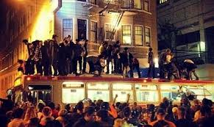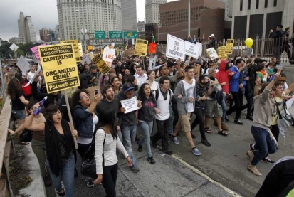 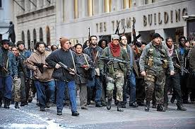

**Jeremiah 51**

**38**Her people all roar like young lions, they growl like lion cubs.  
**39**But while they are aroused, I will set out a feast for them  
    and make them drunk, so that they shout with laughter—  
    then sleep forever and not awake,” declares the Lord.

**45**“Come out of her, my people! Run for your lives!  
    Run from the fierce anger of the Lord.**46**Do not lose heart or be afraid  
    when rumors are heard in the land; one rumor comes this year, another the next, rumors of violence in the land and of ruler against ruler.

**52**“But days are coming,” declares the Lord, “when I will punish her idols,  
and throughout her land the wounded will groan. (Jeremiah 51)

**1.** Jeremiah warns that “all” of the people of the Daughter of Babylon will “roar like young lions” and “growl like lion cubs”. What do you think this could mean?

**2.** Do you see anything going on in the U.S. that could be implied in the above prophecies? How about anything that may happen in the future?

**3.** The five prophets who gave us the 223 verses concerning the Daughter of Babylon prophesy that this end times nation will be totally destroyed. However, since Jeremiah says in 51:52 that “*the wounded will groan”.* In 50:34 Jeremiah says that God will bring *“unrest to those who live in Babylon”*. Do these verses imply that there will be violence in the land *before* the final fall of the nation?

**4.** Jeremiah prophesies “rumors of violence in the land”. In the history of America when have there been instances of violence in the land? What were the causes of the violence?

**5.** Based on history, what would be the likely causes of widespread violence in the U.S. in the future?

**6.** Fifteen Congressmen have written to the Department of Homeland Security demanding an explanation for why the DHS has ordered 1.6 billion rounds of hollow point ammunition. What do you make of the following comment by radio commentator Mark Levin?

“To provide some perspective, experts estimate that at the peak of the Iraq war American troops were firing around 5.5 million rounds per month. At that rate, the [Department of Homeland Security] is armed now for a 24-year Iraq war. A 24-year Iraq war! I’m going to tell you what I think is going on. I don’t think domestic insurrection. Law enforcement and national security agencies, they play out multiple scenarios. … I’ll tell you what I think. They’re simulating: the collapse of our financial system, the collapse of our society and the potential for widespread violence, looting, killing in the streets, because that’s what happens when an economy collapses. I suspect that just in case our fiscal situation, our monetary situation, collapses, and following it the civil society collapses, that is the rule of law, they want to be prepared. I know why the government’s arming up: It’s not because there’s going to be an insurrection; it’s because our society is unraveling.”

**7.** In 2009, President Obama said: *“We cannot continue to rely on our military in order to achieve the national security objectives we’ve set. We’ve got to have a civilian national security force that’s just as powerful, just as strong, just as well-funded.”* Do you see any tie-in between Jeremiah’s prophecies for the Daughter of Babylon and these plans to alter the traditional civilian/military agencies of America?

**EVENT 5 – BLOOD OF THE SAINTS**

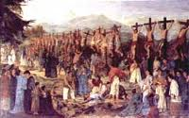 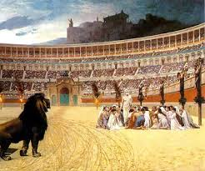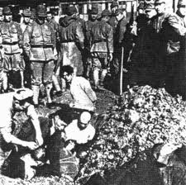

*“I was angry with my people…and I gave them into your hand.” (Isaiah 47:6)*

*“I saw that the woman was drunk with the blood of God’s holy people, the blood of those who bore testimony to Jesus.” (Revelation 17:6)*

*“And in her was found the blood of prophets and of saints and of all who have been slain on the earth.” (Revelation 18:24)*

**1.** Beginning with Stephen, who was martyred for his faith, does the Bible tell us others were martyred?

**2.** Since Biblical days what has been the history of the martyrdom of Christians? What nations have the worst record in killing Christians? (check out [www.VOM.com](http://www.VOM.com) for details)

**3** In your wildest imagination could you conceive of Christians in America being martyred for their faith? Upon what do you base your thoughts?

**4.** Can there be blessings associated with persecution and martyrdom of God’s people? If so, what are those blessing? (Acts 11:19-20).

**5.** Assume that the U.S. Supreme Court rules in either the Prop 8 or DOMA cases that same sex marriage is the law of the land (or alternative B – the President issues an Executive Order or Alternative C - Congress enacts such a law). First, will Christians generally bow to the law and/or not object to it, for example allowing same sex marriages in church facilities? Second, how should Christians who refuse to bow to the law react to governmental demands to do so? Is civil disobedience a Biblical response? What scripture do you see as supporting your answer? Do you think that Acts 5:29 applies?

**6.** In the history of the world, mass murders, real mass murders of large numbers of people have taken place at the hands of governments killing their own people. Besides opposition by gay rights activists, can you envision any other reason why the Daughter of Babylon will slaughter God’s people?

**7.** If Christians begin to be targeted and slaughtered by their government, will they flee from their nation? Why? Why not?

**EVENT 5 - Are Rumors One Year Apart a Timing Sign?**

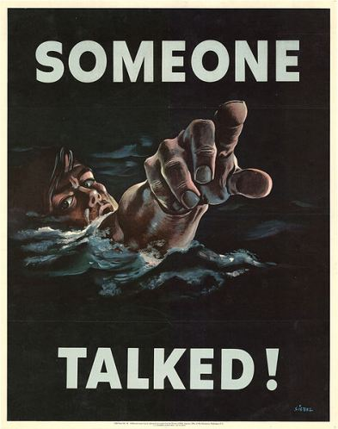

*“My people, go out of the midst of her! And let everyone deliver himself from the fierce anger of the Lord.* ***46****And lest your heart faint, And you fear for the rumor that will be heard in the land (A rumor will come one year, And after that, in another year A rumor will come, And violence in the land, Ruler against ruler)* (Jeremiah 51:45-46-NKJV)

*“As Jesus was sitting on the Mount of Olives, the disciples came to him privately.” Tell us,” they said, “when will this happen…”* (Matthew 24:3)

*“A prudent man sees danger and takes refuge, but the simple keep going and suffers for it.”* (Proverbs 22:3)

**1.** Jeremiah in 51:45-46 gives us an interesting insight into events in the Daughter of Babylon *before* its final destruction. In verse 47, which follows, he prophesies that *“Therefore behold, the days are coming….(that) all her slain shall fall in her midst.”* Thus, the rumors that will circulate in the Daughter of Babylon obviously happen before its fall. Do you think Jeremiah/the Lord are giving us a timing sign? What would that look like?

**2.** The word “rumor” is used elsewhere in scripture? When the word is used what does it appear to mean? (II Kings 19:7 and Isaiah 37:7; Nehemiah 6:6; Matthew 24:6 and Mark 13:7). Does there appear to be any doubt as to the meaning of the word?

**3.** Let’s look at what Jeremiah prophesied:

A.) A rumor circulates in the country that there is great violence and that a ruler (President/Governor/Senator/House Speaker??) is engaged in violent acts against another ruler.

B.) One year passes.

C.) Another rumor circulates in the country of great violence and a ruler engaged in violence with another ruler

If you are still living in the United States when these rumors circulate widely in the country do you arrive at any conclusions? What? If you are in the U.S. for the first rumor, do you flee at that point in time? Or, instead, do you wait for the second rumor to be circulated? Do you still stay after the second rumor? On what do you base your decision?

**4.** How are your answers above affected by the timing of Israel signing a peace treaty? If Israel had signed a peace treaty before the rumors would that make your exit from the US more likely?

**5.** Alternatively, if Israel had not yet signed a peace treaty at the time of the rumors one year apart, how does that affect your answer? To which of these three time schedules do you subscribe? What is the basis of your decision?

1.) LEAVE NOW –

2.) LEAVE ONCE ISRAEL IS ‘AT PEACE’ –

3.) LEAVE ONCE AMERICA STABS ISRAEL IN THE BACK–

**Event 6 – The Daughter of Babylon/America Betrays Israel**

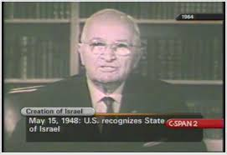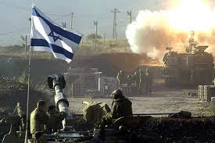 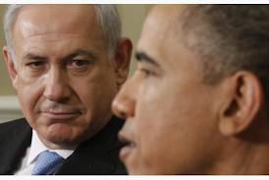

In Lesson Sixteen (Event 3) we studied the prophecies that Israel would return to the land (Ezekiel 36:8) and would eventually be at peace (Ezekiel 38:8, 11 and 14 and 39:26). Thus, once Israel has returned to the land (Harry S Truman recognized Israel ten minutes after it self-declared its sovereignty) and is a signator to a peace agreement the stage will be set for Israel’s betrayal.

**1.** We saw in Lesson Sixteen that God told Israel not to give up His land and not to rely on peace agreements with other nations. On June 14, 2009 Prime Minister Benjamin Netanyahu gave a speech in Israel reversing his lifetime position opposed to giving up land to the Palestinians. He said, in part:

“But, friends, we must state the whole truth here. The truth is that in the area of our homeland, in the heart of our Jewish Homeland, now lives a large population of Palestinians. We do not want to rule over them. We do not want to run their lives. We do not want to force our flag and our culture on them. In my vision of peace, there are two free peoples living side by side in this small land, with good neighborly relations and mutual respect, each with its flag, anthem and government, with neither one threatening its neighbor's security and existence….  I told President Obama in Washington, if we get a guarantee of demilitarization, and if the Palestinians recognize Israel as the Jewish state, we are ready to agree to a real peace agreement, a demilitarized Palestinian state side by side with the Jewish state.”

Netanyahu campaigned for office *against* the “*two state solution*”. After his June 2009 speech he affirmed that he had changed his position and would agree to give up ‘land for peace’. In 2010 he said he was willing to make “*unprecedented concessions*”. President Obama recently visited Israel for the first time in his presidency. In light of prophecy, do you see a pattern forming on the global stage in which Israel will likely enter into a peace agreement? What is the downside for Israel if it does so?

**2.** When Israel agrees to give up some of its (His) land to the Palestinians the peace agreement will be crafted in large part by the U.S., with assurances of undying support for Israel by America. On March 26, 1979 President Carter entered our nation into a “*Memorandum of Agreement Between the Governments of the United States of America and the State of Israel”*. The agreement induced Israel to enter into a separate peace agreement with Egypt. Former President Morsi of Egypt (a member of the Muslim Brotherhood) made it clear that he intended to abrogate the agreement with Israel. In 2004 President George W. Bush promised Israel that the US would support Israel on four key points. But, it reversed positions in 2008 saying those promises were *“about realities at that time. And there are (now) realities for both sides…”*

President Obama recently said (source: White House Website):

**“Our commitment to the security of Israel is rock solid.  And as I've said to the Prime Minister in every single one of our meetings, the United States will always have Israel's back when it comes to Israel's security.  This is a bond that is based not only on our mutual security interests and economic interests, but is also based on common values and the incredible people-to-people contacts that we have between our two countries.”**

**President Barack ObamaMarch 5, 2012**

What is your level of confidence that the United States will keep its word made to Israel through three Presidents?

**3.** Does your view of America’s support for Israel change when you read the following concerning the Daughter of Babylon/Mystery Babylon/Babylon the Great? (The verses refer to Israel’s invasion by Russia, Iran and Libya as set forth in detail in Ezekiel 38 and 39.)

*“A dire vision has been shown to me:   
 The traitor betrays, the looter takes loot.   
 Elam, attack! Media, lay siege!   
 I will bring to an end all the groaning she caused.”* (Isaiah 21:2)

*“I will take vengeance;   
 I will spare no one.”* (Isaiah 47:3)

*“Before your eyes I will repay Babylon and all who live in Babylonia for all the wrong they have done in Zion,” declares the LORD.”* (Jeremiah 51:24)

*“May the violence done to our flesh be upon Babylon,”*

*say the inhabitants of Zion.   
 ‘May our blood be on those who live in Babylonia,’   
 says Jerusalem. Therefore, this is what the LORD says: ‘See, I will defend your cause and avenge you’…”* (Jeremiah 51:35-36)

*“Babylon must fall because of Israel’s slain,   
 just as the slain in all the earth   
 have fallen because of Babylon.”* (Jeremiah 51:49)

*“A destroyer will come against Babylon;   
   her warriors will be captured,   
   and their bows will be broken.   
 For the LORD is a God of retribution;   
 he will repay in full.”* (Jeremiah 51:56)

*“O Daughter of Babylon, doomed to destruction,   
 happy is he who repays you   
 for what you have done to us”* (Psalm 137:8)

‘The Message’ translation of Lamentations 4:17 reads:

*“We watched and watched,   
  wore our eyes out looking for help. And nothing.  
 We mounted our lookouts and looked   
    for the help that never showed up.”*

Do these prophetic verses sound like the Daughter of Babylon will “*have Israel’s back*” or, instead, that it will ‘*stab Israel in the back*’? We’ll discuss the issues of America keeping its word, Israel’s right to rely on a treaty partner and what we can discern from these verses.

**4.** A.) If the United States is the Daughter of Babylon (high level of likelihood);

B.) Israel enters into a peace agreement (God says they will);

C.) Israel is invaded during the time is at peace (see Ezekiel 38/39);

D.) The Daughter of Babylon betrays Israel, refusing to come to its assistance.

Will those who are in the US have the luxury of time to flee once Israel is betrayed? What is the basis of your answer and conclusions? If they don’t have that luxury, what is the safest course of action?

**5.** Back to a question raised early in our study. Why should Genesis 12:3 (God promises to bless those who bless Israel and curse those who curse Israel.) trump the fact that America has in past years been a “golden cup” in God’s hand, used to spread the Gospel and advance missions around the globe? Is it fair? Is that the right question?

**6.** God told Israel not to enter into peace agreements with other nations. Is there a downside to America entering into military defense agreements with other nations? What are those downside risks? George Washington warned about “foreign entanglements”. In light of the last 226 years did he have a point?

**CLOSING THOUGHTS**

We have now studied in some depth the Biblical prophecies of the Daughter of Babylon/Babylon the Great and the thirty clues to the identity of Mystery Babylon. If the student is convinced that America is the Daughter of Babylon/Babylon the Great, then that knowledge should become more than just head knowledge. The Bible warns Christian and Jewish residents of the Daughter of Babylon TEN times to *flee* from the nation. *To run. To run for your lives. Come out. Escape.* Read Chapter Thirteen of THE END OF AMERICA for more details, including the locations of the ten warnings in the Bible and which nations are good candidates for a new home. When God tells us something ten times He must be quite interested in our obedience. *Pray about responding to these warnings by fleeing.* The author has been a resident of Central America for over a year. Along with his wife they are active in a growing start-up English speaking church, whose members are excited about the ministry opportunities among people who are actually interested in hearing the Gospel. The Bible is full of instances in which God moved His people to accomplish His purposes. Are you willing to obey by fleeing?

If the student has not yet read the full text of THE END OF AMERICA, this would be a good time to do so. It’s available on Kindle for ninety-nine cents so that the maximum number of Americans can read it. THE END OF AMERICA is non-fiction. Some readers prefer to read fiction (with facts mixed in). For those readers, you may wish to read SECOND TERM and THE WARNING, which are novels based on THE END OF AMERICA. They are the first two books in a trilogy. The third book, THE DAY, will be published in 2014.

For serious students who want to dig deeper into what the Bible prophesies about a rich, powerful and influential end times nation, please go to [www.endofamericabook.com](http://www.endofamericabook.com). Click on the Prophecy tab. You will have the choice of an article entitled Prophecy 101 and another detailing the Scripture analyzed in THE END OF AMERICA, including a look at Hebrew and Greek source words. If you click on the NEWS tab you can read newsletters from the past three years sent to persons who sign up on the website for the free newsletter. If you are interested in receiving the newsletter, feel free to sign up on the website. I won’t besiege you with lots of newsletters, I do 4 to 6 a year. The EMAIL THE AUTHOR tab allows us to communicate by way of e-mail. Below are some other sources of research. Thanks for reading and studying. God bless.

John Price

**BIBLIOGRAPHY**

* *America in Prophecy*, (Inspiration Books East, Inc., Jemison, Alabama, 1988)
* Bawer, Bruce, *While Europe Slept: How Radical Islam is Destroying the West from Within,* (Broadway Books, New York, 2006)
* Ben-Mardechai, Avi, *Signs in the Heavens,* Millennium 7000 Communications International, 1995)
* Blum, William, *Rogue State & Guide to the World’s Only Superpower*, (Common Courage Press, Monroe, Maine, 2005)
* Bostom, Andrew G., *The Legacy of Jihad: Islamic Holy War and the Fate of Non-Muslims*, (Prometheus Books, Amherst, New York, 2005)
* Boyer, Paul S., *When Time Shall Be no More: Prophecy Belief in Modern American Culture*, (Harvard College, 1992)
* Carter, Jimmy, *We Can Have Peace in the Holy Land: A Plan that will Work*, (Simon & Schuster, New York, New York, 2009) (I list this book, but it’s not recommended as the former President attacks Israel on its pages.)
* Criswell, David, *She Who Restores the Roman Empire*, (Writers Club Press, 2002)
* D’Souza, Dinesh, *What’s So Great about Christianity*, (Tyndale House Publishers, Inc., Wheaton, Illinois, 2008)
* Doyle, Tom, *Two Nations under God*, (B&H Publishing Group, Nashville, Tennessee, 2004)
* Ehrman, Mark, *Getting Out* - *Your Guide to Leaving America* (Process Media, Los Angeles, California, 2006)
* Evans, Michael D. and Jerome R. Corsi, *Showdown with Nuclear Iran: Radical Islam’s Messianic Mission to Destroy Israel and Cripple the United States,* (Nelson Current, Nashville, Tennessee, 2006)
* Evans, Mike, *The Return,* (Thomas Nelson, Inc., Nashville, Tennessee, 1986)
* Foxe, John, *New Foxe’s Book of Martyrs* *2001*, (Bridge-Logos Publishers, Gainesville, Florida, 2001)
* Gabriel, Brigitte, *Because They Hate,* (St. Martin’s Press, New York, New York, 2006)
* Gabriel, Mark A., *Islam and the Jews,* *The Unfinished Battle* (Lake Mary, Florida, Charisma House, 2003)
* Gabriel, Mark A., *Islam and Terrorism*, Strang Communications/Charisma house, Lake Mary, Florida, 2002)
* Gabriel, Mark A., PhD, *Jesus and Muhammad*, (Strang Communications/Charisma House, Lake Mary, Florida, 2004)
* George, Barney, *All Nations Against Jerusalem,* (Christ for the World, Orlando, Florida 32802)
* Grant, George, *The Blood of the Moon*, (Wolgemuth & Hyatt, Brentwood, Tennessee, 1991)
* Henry, Matthew, *Matthew Henry Complete Commentary on the Whole Bible*, (Hendrickson, 1991)
* Hersey, John, *Hiroshima*, (A.A. Knopf, New York, 1985)
* Hislop, Rev. Alexander, *The Two Babylons,* (Loizeaux Brothers, Neptune, New Jersey
* Hitchcock, Mark, *Is America in Bible Prophecy?* (Multnomah Publishers, Inc., Sisters, Oregon, 2002)
* Hitchcock, Mark, *The Coming Islamic Invasion of Israel*, (Multnomah Publishers, Inc., Sisters, Oregon, 2002)
* *Israel - America’s Key to Survival*, Tyndale House Publishers, Wheaton, Illinois, 1983)
* Jeremiah, David, *What in the World is Going On? : 10 Prophetic Clues you Cannot Afford to Ignore,* (Thomas Nelson, Nashville, Tennessee, 2008)
* Koenig, William R., *Eye to Eye – Facing the Consequences of Dividing Israel,* (About Him, Alexandria, Virginia, 2007)
* Lightle, Steve, *Exodus II - Let My People Go!* (Hunter Books, Kingwood, Texas 1983)
* Lindsay, Hal, *The Late Great Planet Earth*, (Zondervan, Grand Rapids, Michigan, 1970)
* Logsdon, Dr. S. Franklin, *Is the U.S.A. in Prophecy?* (Zondervan Publishing House, Grand Rapids, Michigan,1968, 1974)
* McKeever, James M., *Christians Will go Through the Tribulation and How to Prepare for it,* (Alpha Omega Publishing Company, Medford, Oregon, 1978)
* McTernan, John, *God’s Final Warning to America*, (Hearthstone Publishing, Oklahoma City, OK, 2000)
* Phillips, Melanie, *Londonistan*, (Encounter Books, New York, New York, 2006)
* Richardson, Joel, *AntiChrist - Islam’s Awaited Messiah* (Pleasant Word, Enumclaw, Washington, 2006)
* Richardson, Joel, *The Mideast Beast, The Scriptural Case for an Islamic Antichrist* (MND Books, 2012)
* Rosenthal, Marvin J., *The Prewrath Rapture of the Church* (Thomas Nelson, Inc., Nashville, Tennessee, 1990)
* Showers, Dr. Ronald, *What on Earth is God Doing?* (Loizeaux Brothers, Inc., Neptune, New Jersey, 1973)
* Steyn, Mark, *America Alone: The End of the World as we Know It*, (Regnery Publishing, Inc., Washington, DC, 2006)
* Sumrall, Lester F., *Jerusalem, Where Empires Die*, (Sumrall Publishing, South Bend, Indiana, 1979)
* *The Nations in Prophecy*, (Zondervan Publishing House, Grand Rapids, Michigan, 1967)
* Weber, Timothy P., *The Future Explored*, (Victor Books, Wheaton, Illinois)
* Williams, Paul L., *The Day of Islam: The Annihilation of America and the Western World*, (Prometheus Books, Amherst, New York, 2007)
* Wildmon, Donald, *Speechless: Silencing the Christians*, (Richard Vigilante Books, 2009)
* Zakaria, Fareed, *The post-American world*, (W.W. Norton & Company, Inc., New York, New York, 2008)

**NOVELS**

(Listed for readers interested in fictional

treatment of nuclear destruction.)

* Allen, Steve, *The Shell Game*, (Sweetwater Books-an imprint of Cedar Fort, Inc., Springville, Utah, 2007)
* Brin, David*, The Postman,* (Bantam Books, New York, New York, 1985)
* Forstchen, William R., *One Second After*, (A Forge Book published by Tom Doherty Associates, LLC, New York, New York, 2009)
* Frank, Pat, *Alas, Babylon*, (Harper Collins Publishers Inc., New York, New York, 1959)
* Strieber, Whitley, *Critical Mass,* (Forge Book, New York, New York, 2009)